1.

Create a API gateway

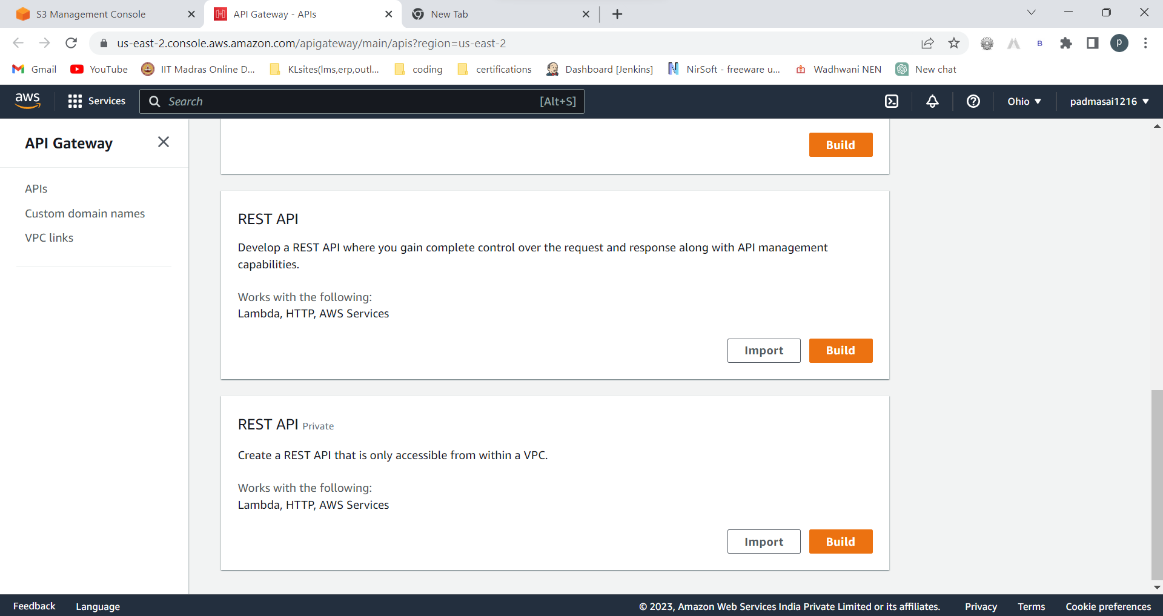

Choose REST API

Build

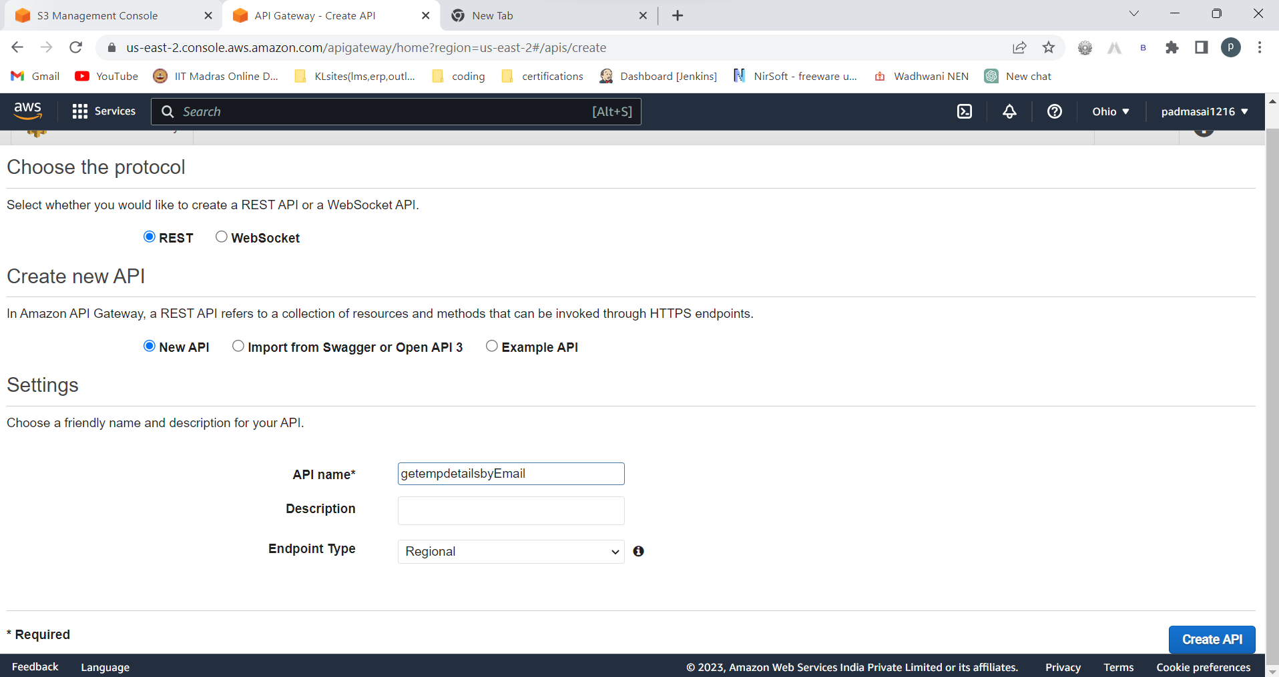

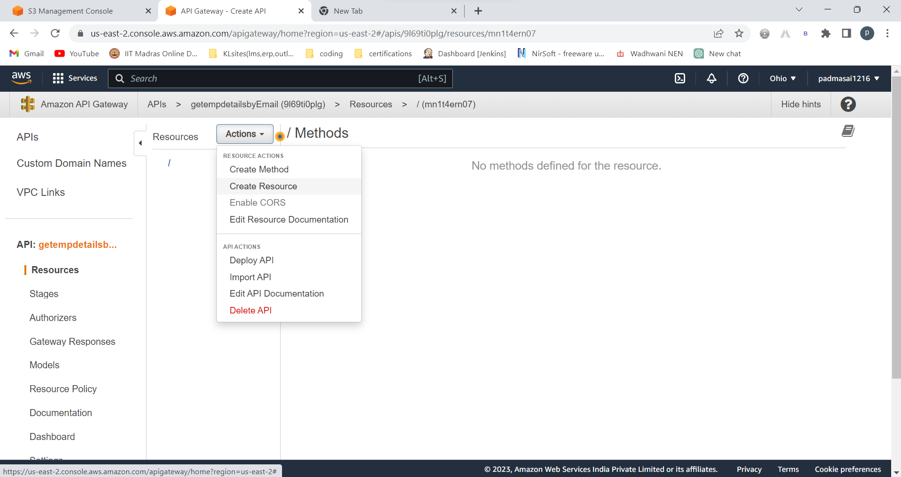

Actions 🡪create resource

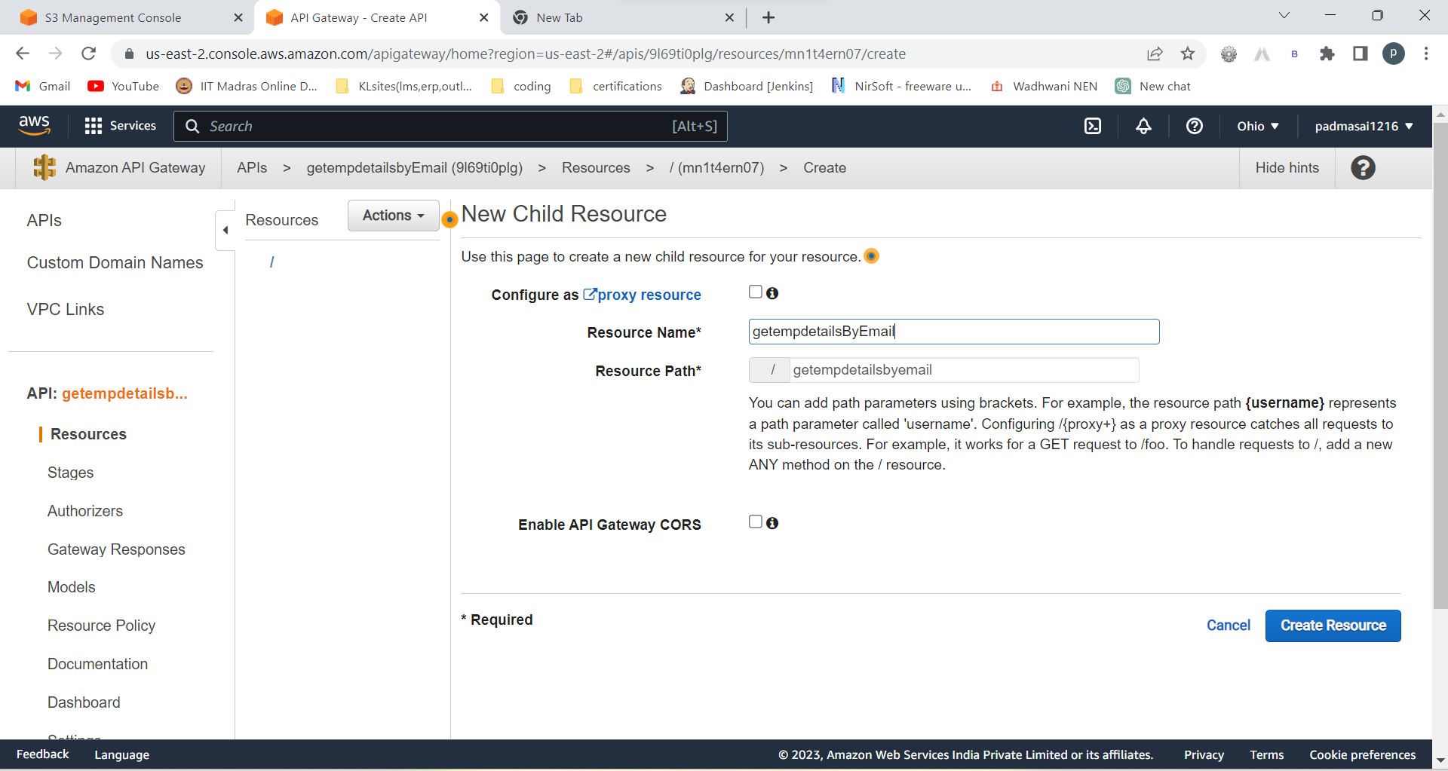

Create resource

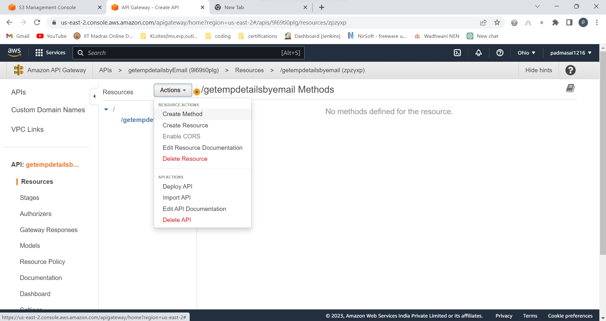

Select /getempdetailsbyEmail 🡪actions 🡪create method 🡪choose get 🡪click on tick

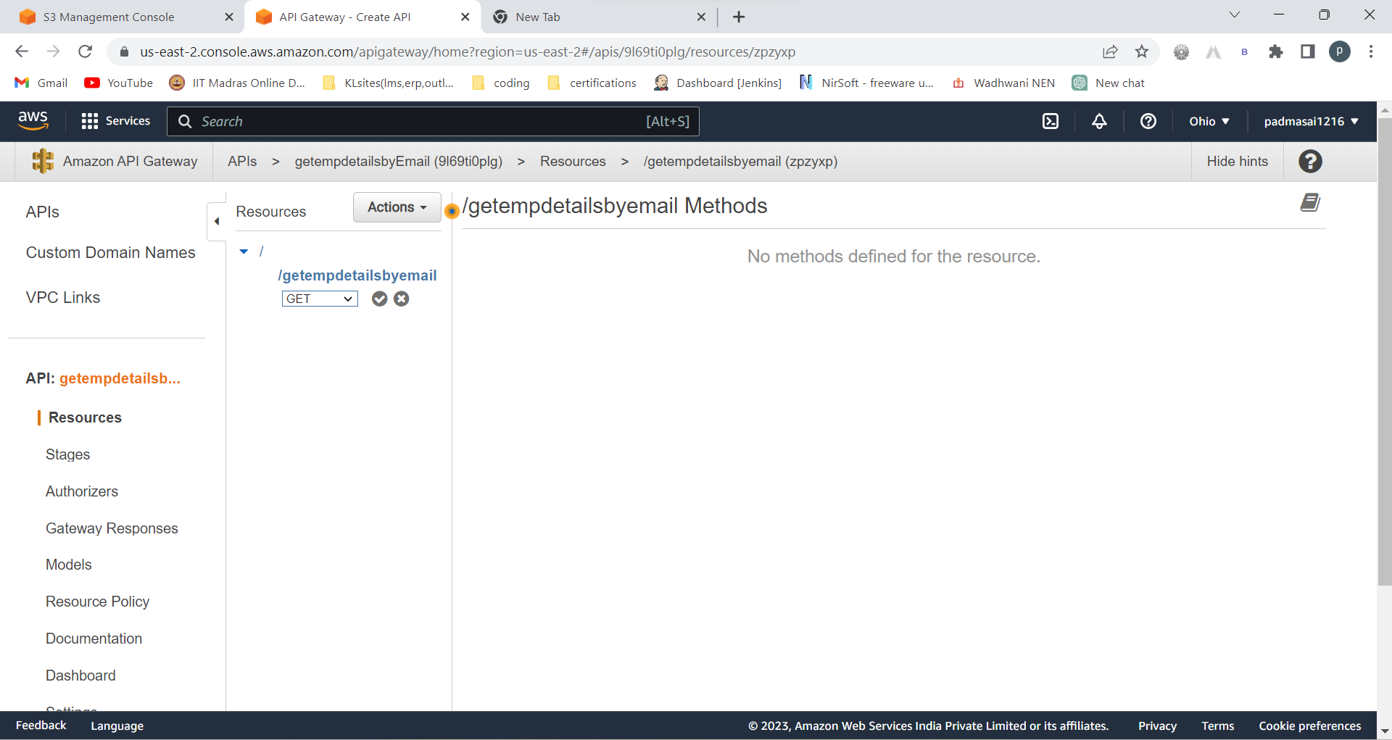

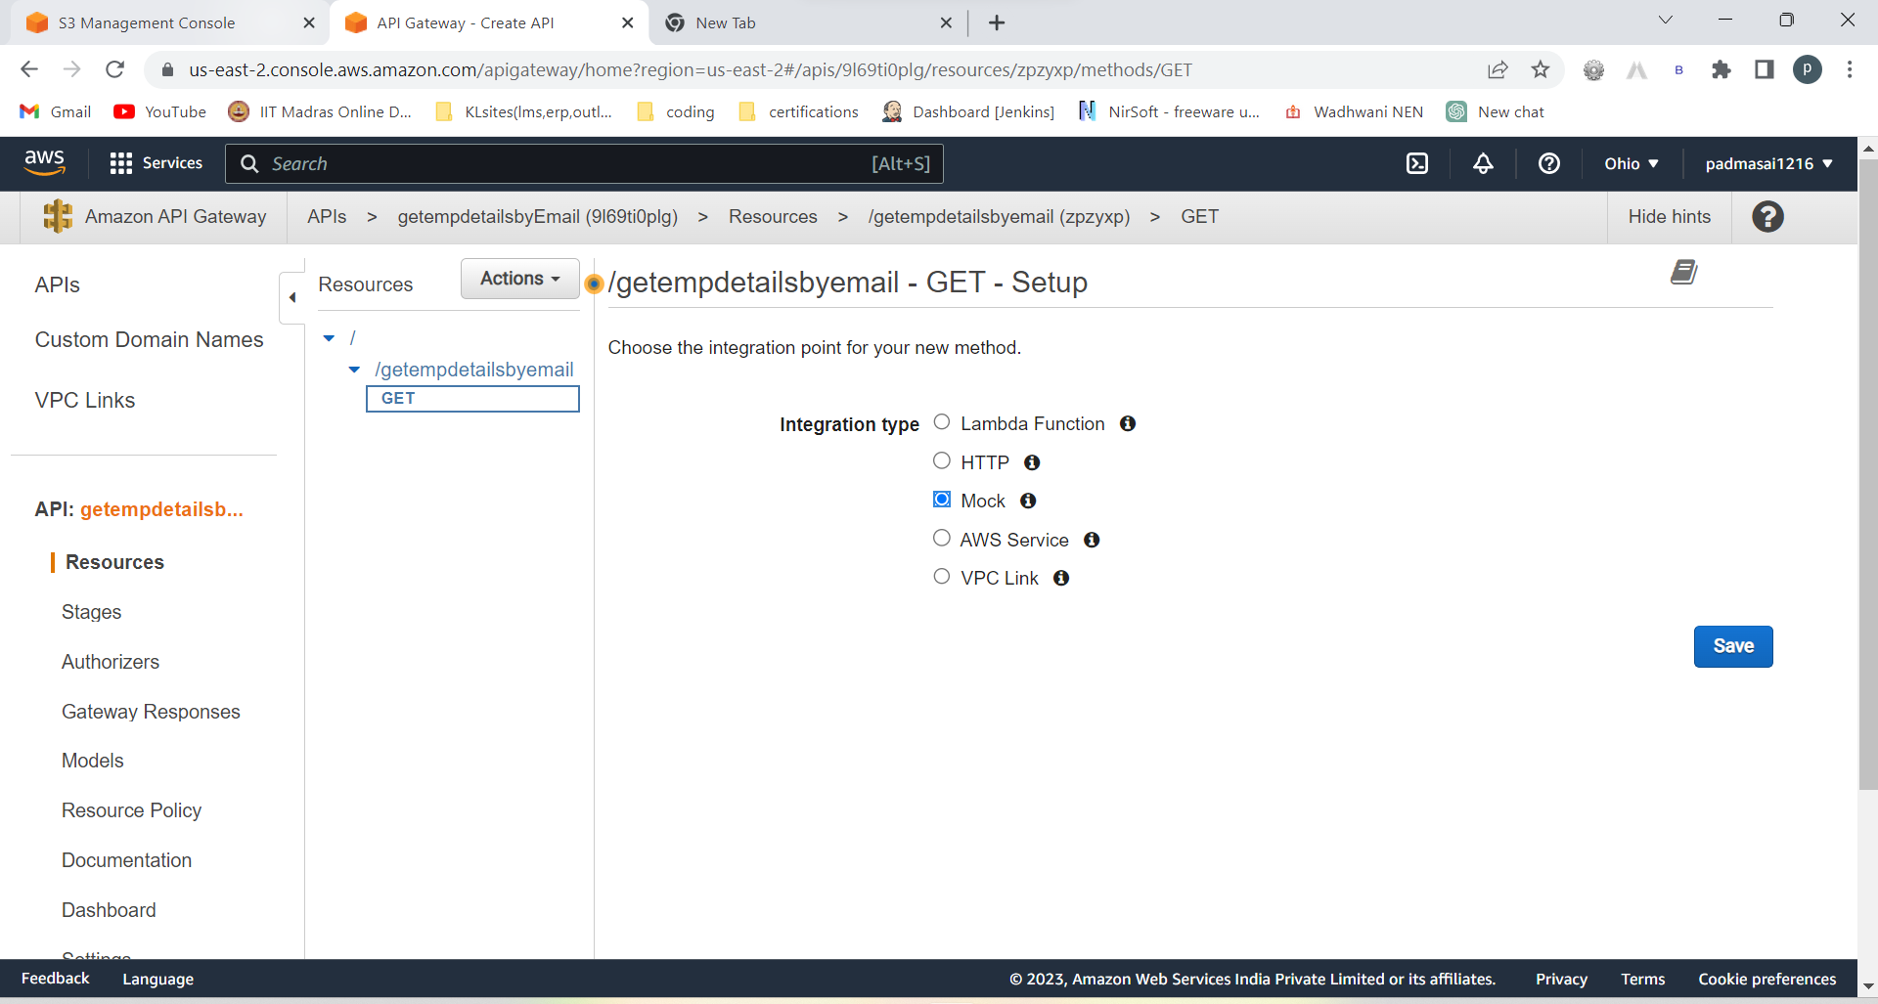

Go to integration response:

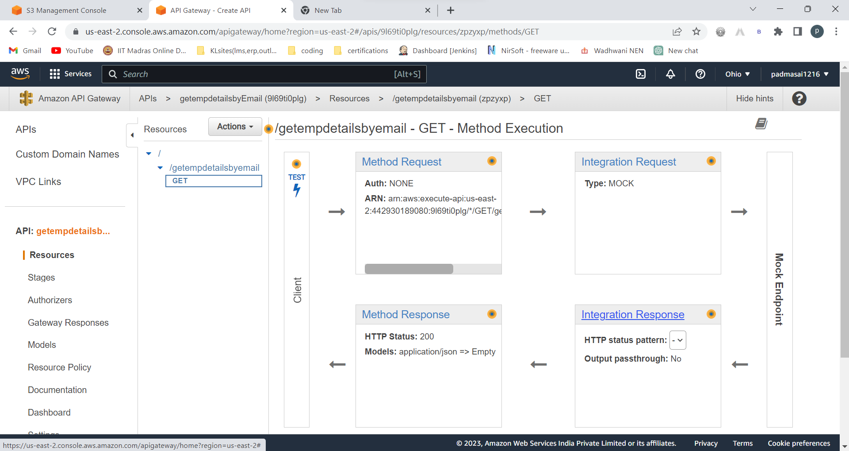  
mapping templayte 🡪 add mapping template🡪(application/json)

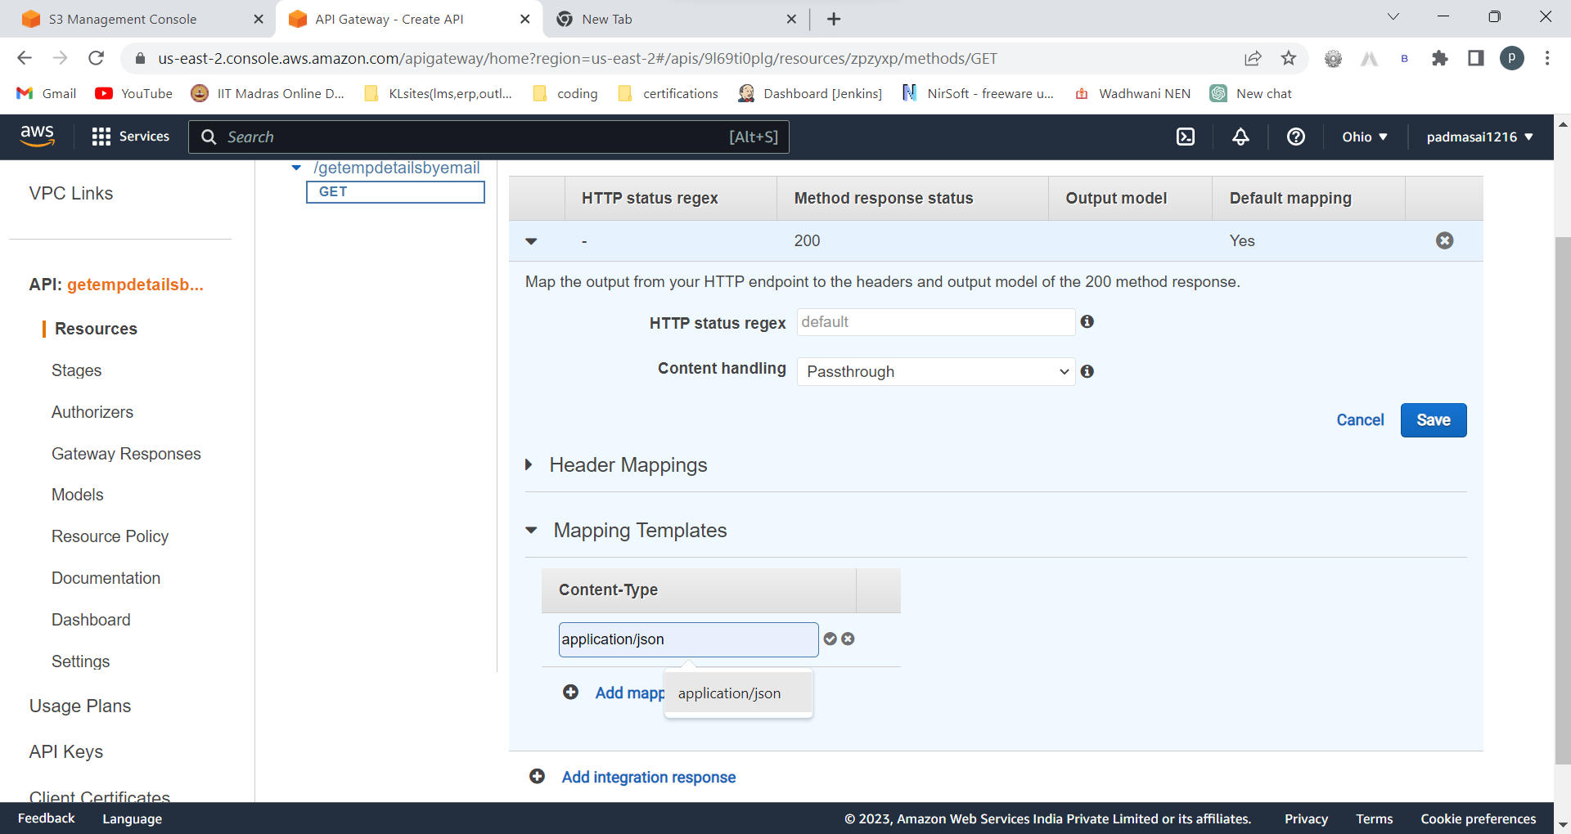

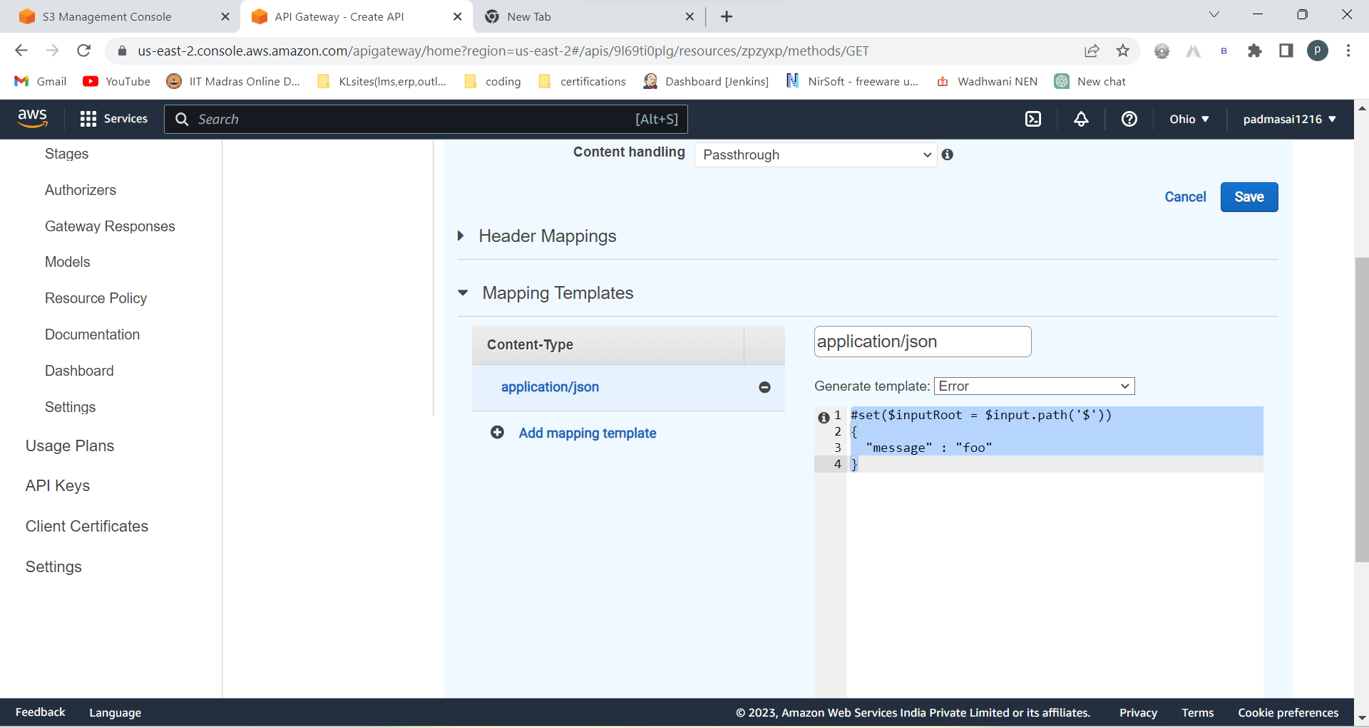

Generate template : Error

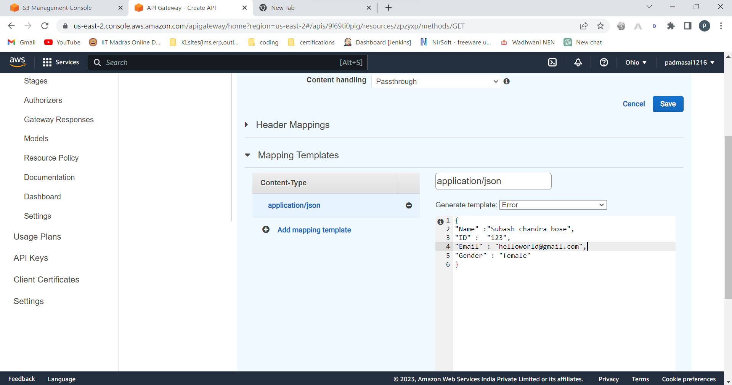

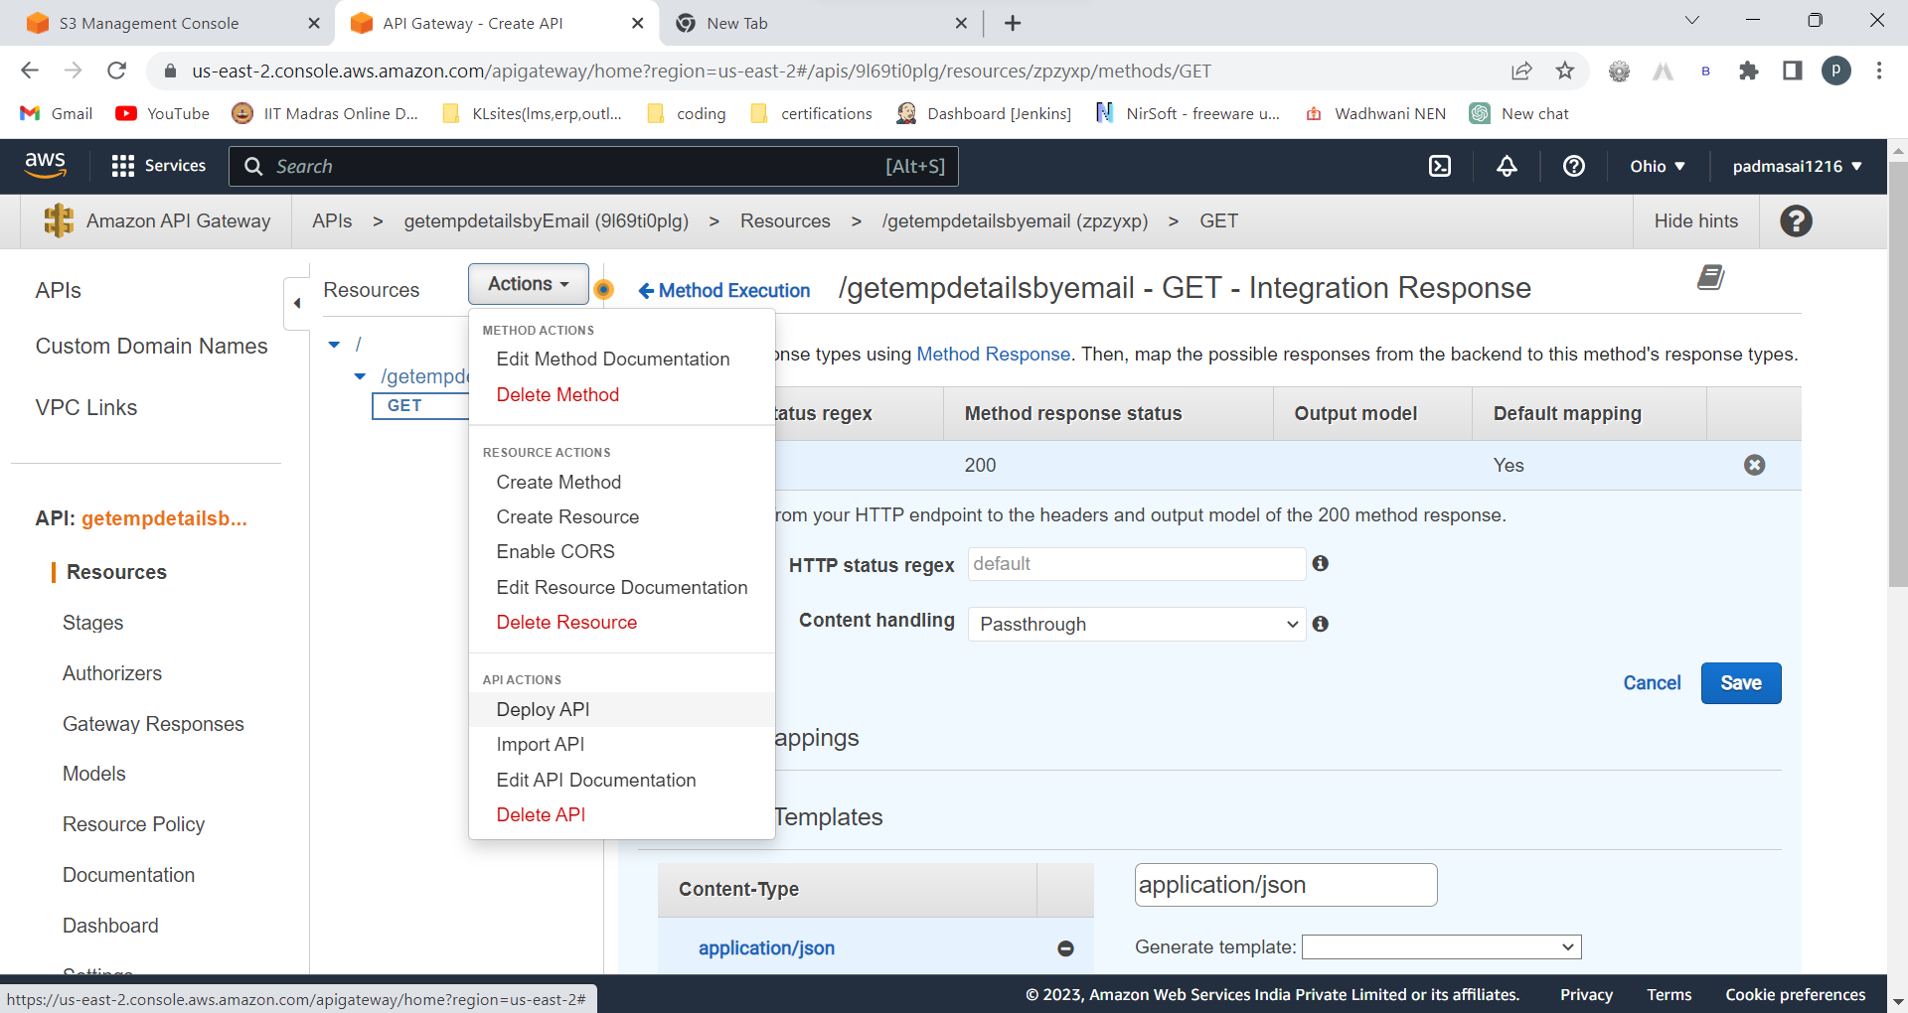

Deploy API

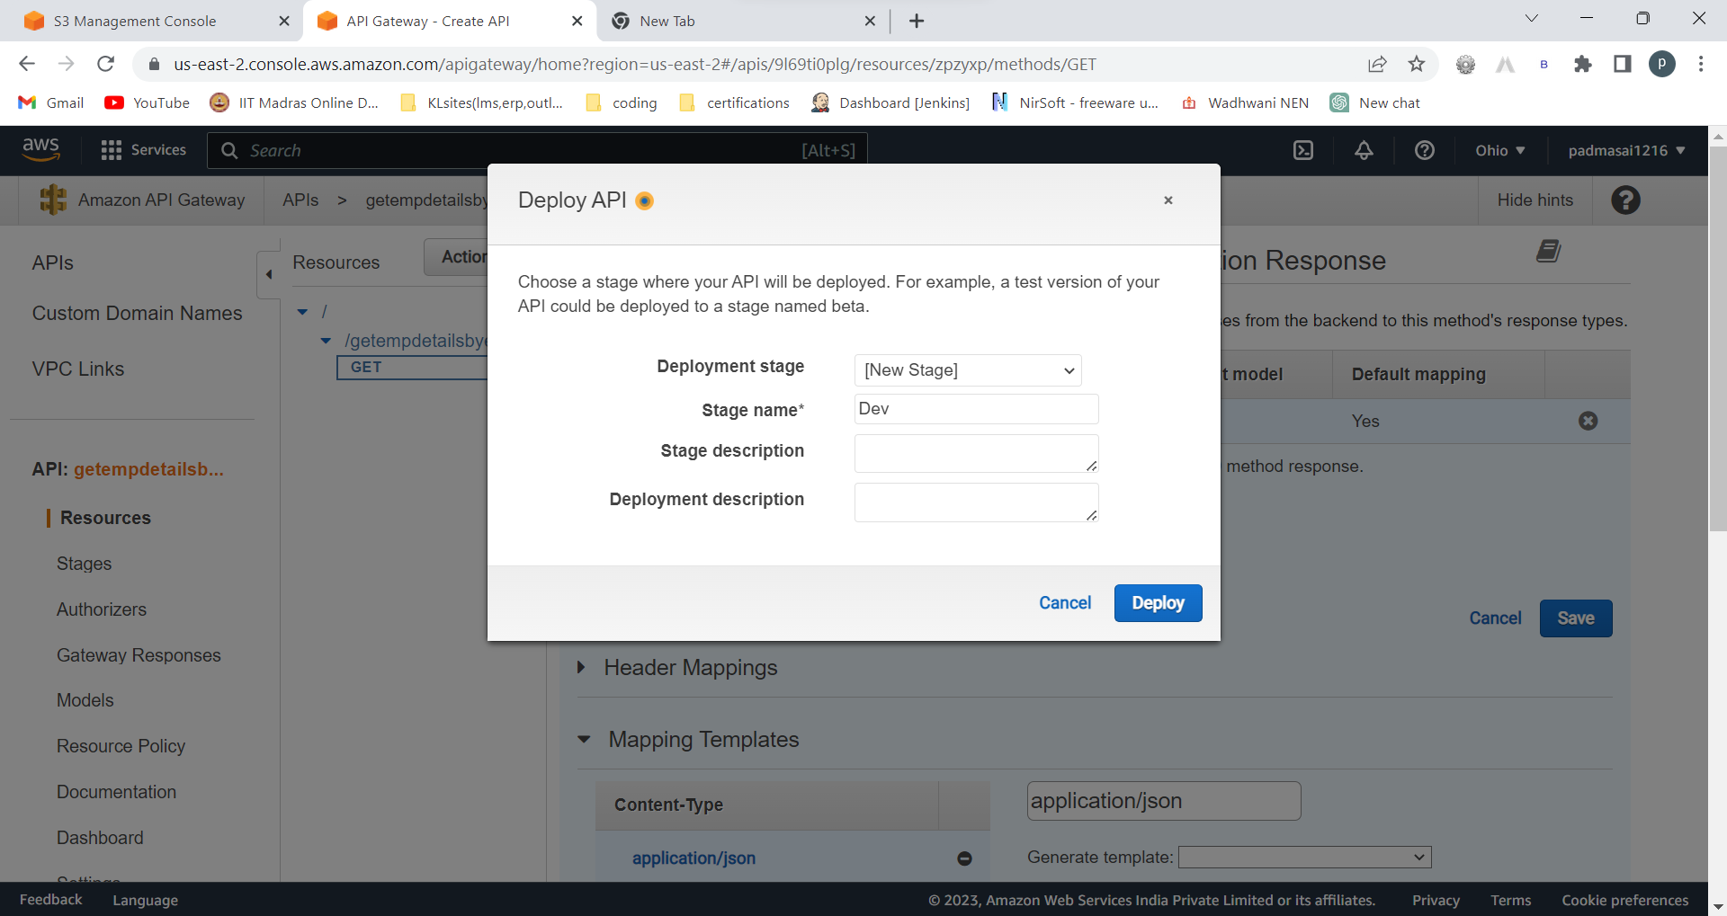

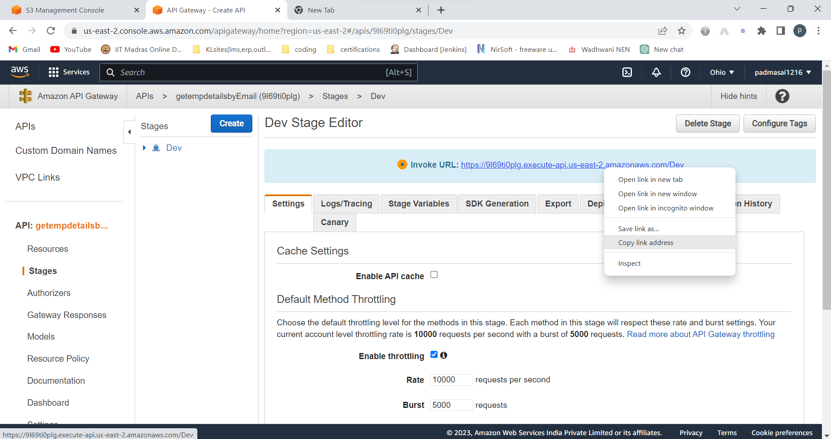

Copy this invoke url and paste it in postman API

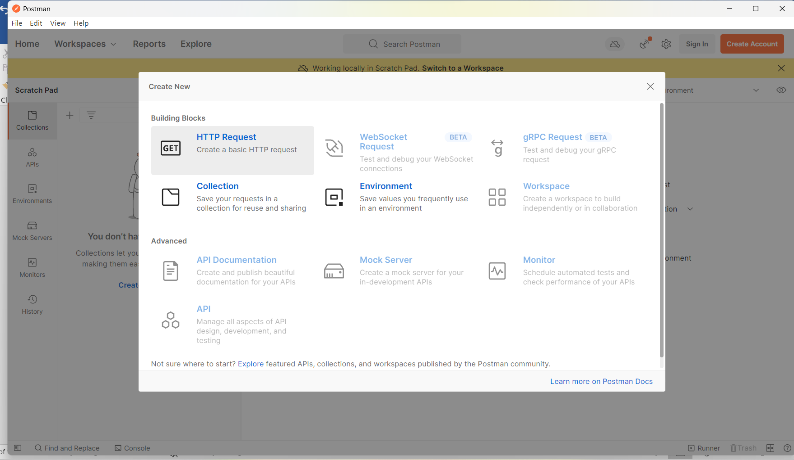

New 🡪http request 🡪

Copy paste the invoke url in postman API to check and at the end of URL add (/resource name)

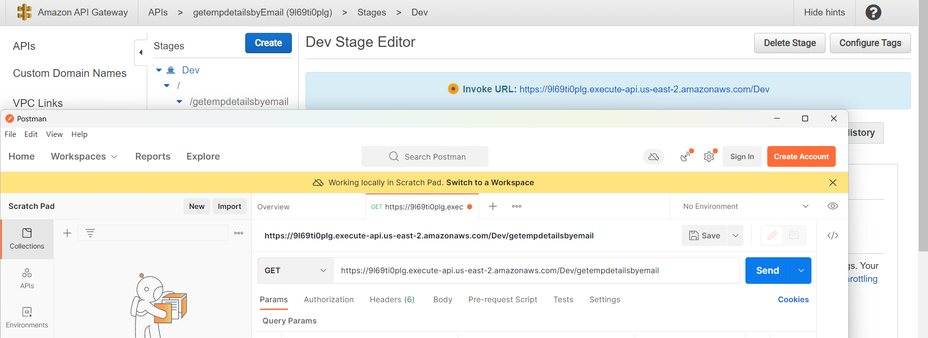

Under dev 🡪/--? Getemployeedetailsbyemail(resource name)

This should be added at the end of the url in postman

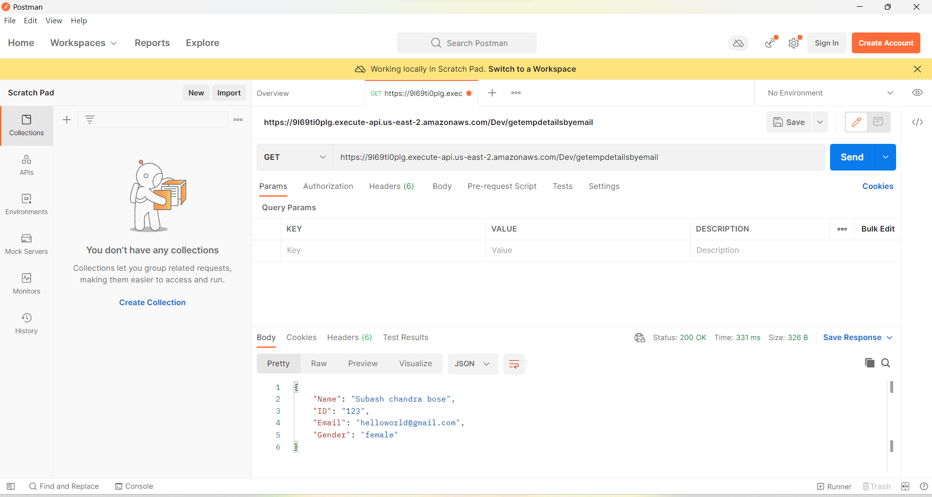

Success!!!

Create a IAM role with use case lambda :

Lambda full access, dynamodb full access permission policies

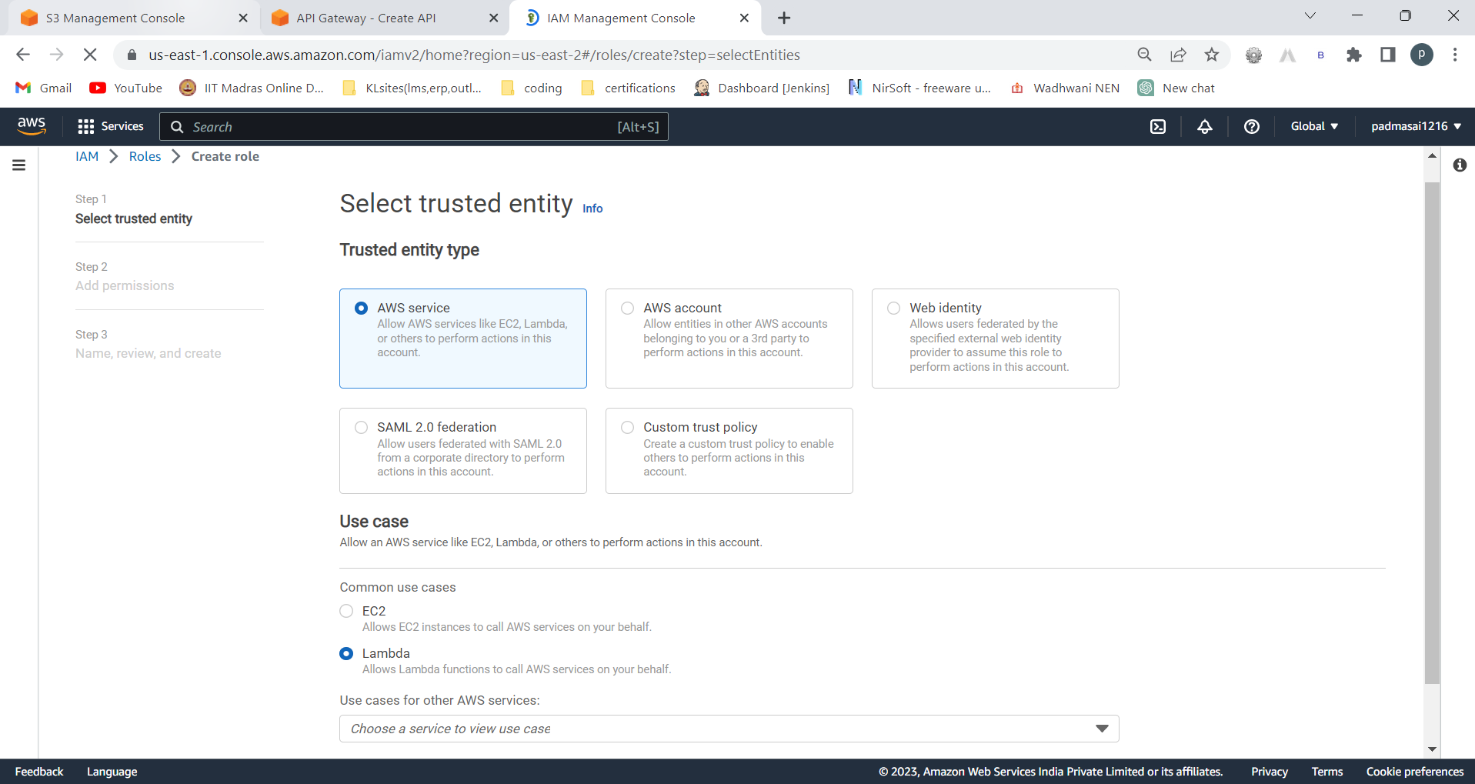

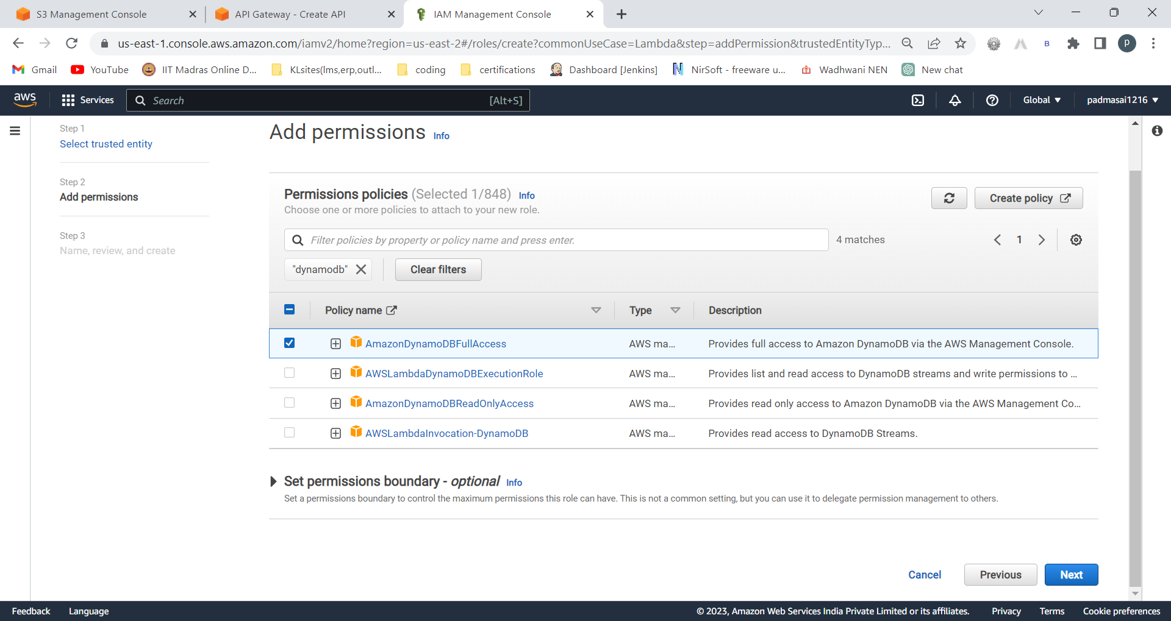

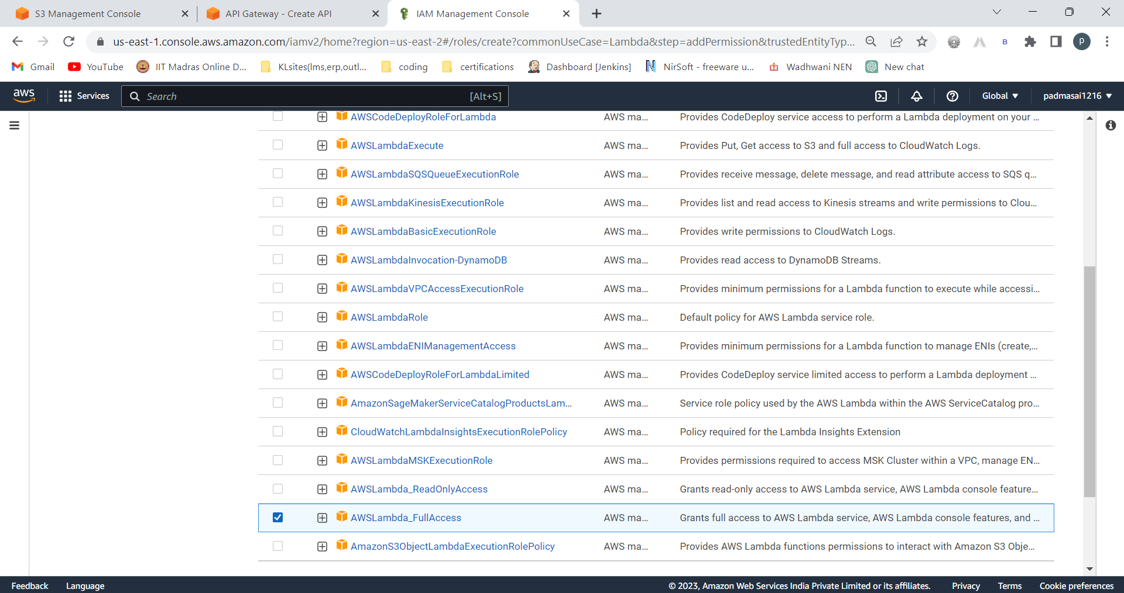

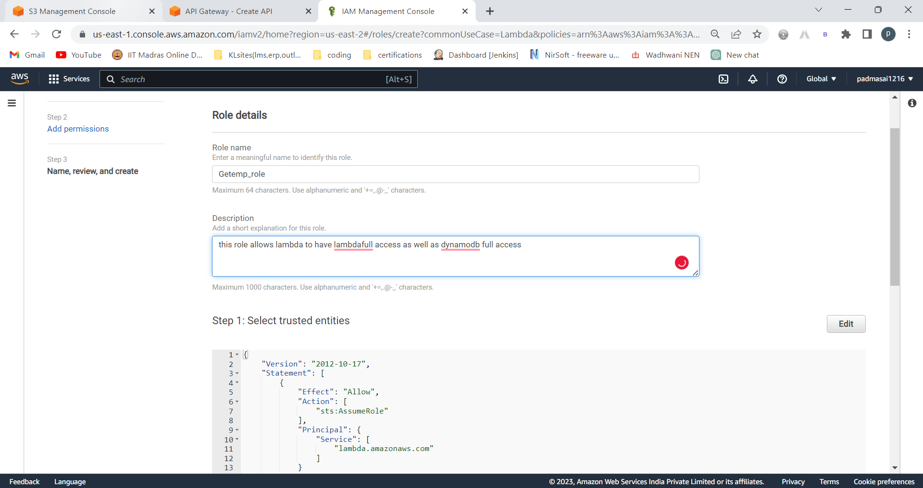

Create role

Creating lambda:

Function name:

GetEmpdetailsByEmail

Node must be of 16.x version of node.js

Attach above role

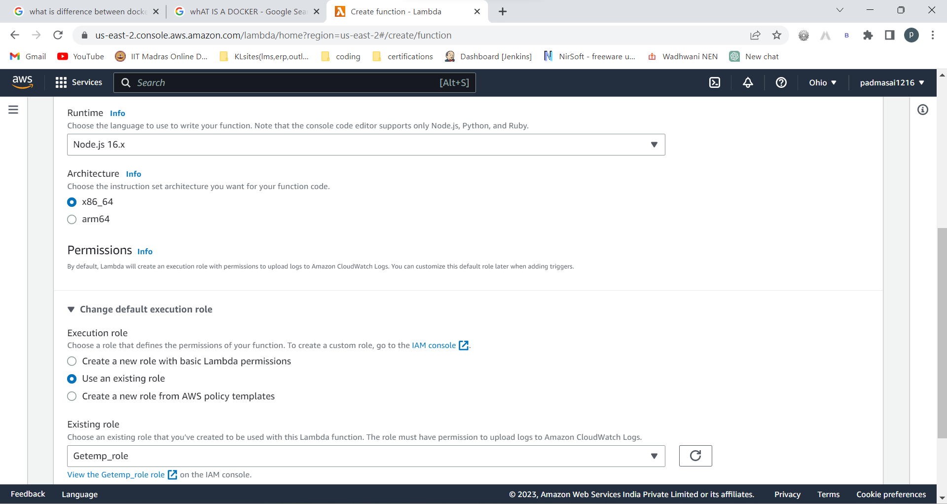

Create function

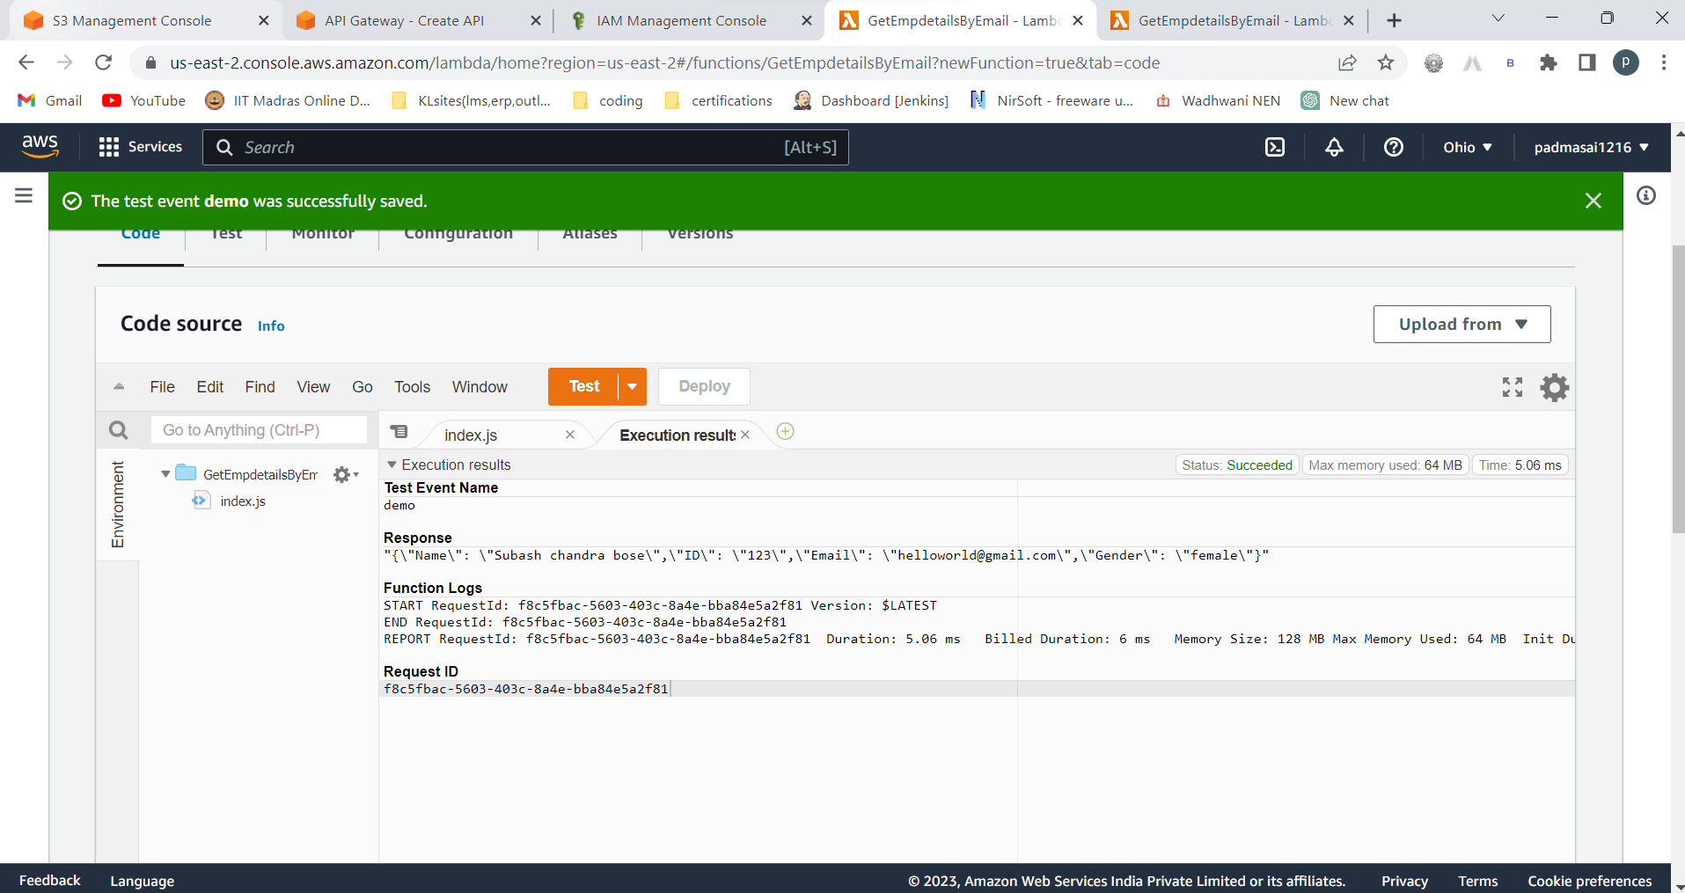

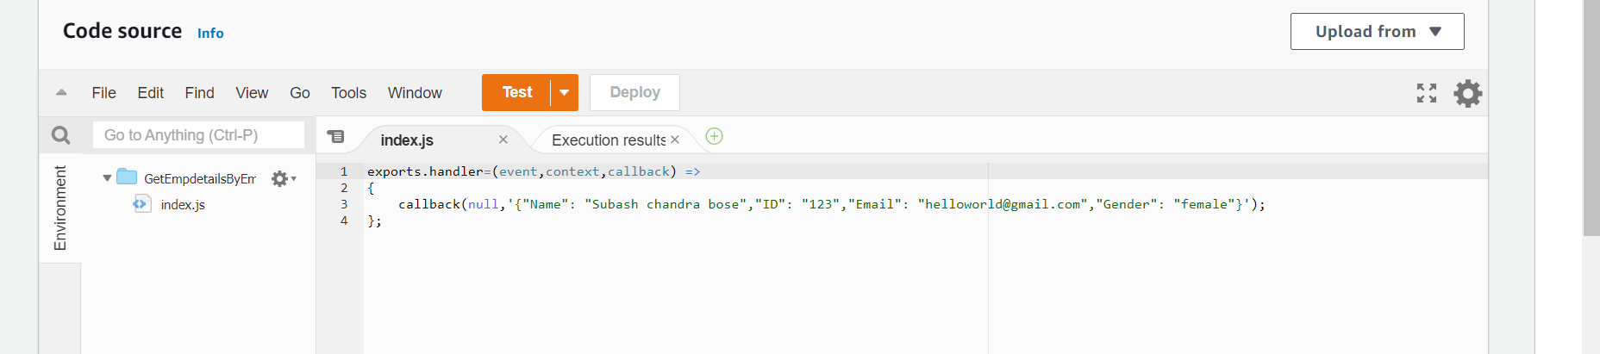

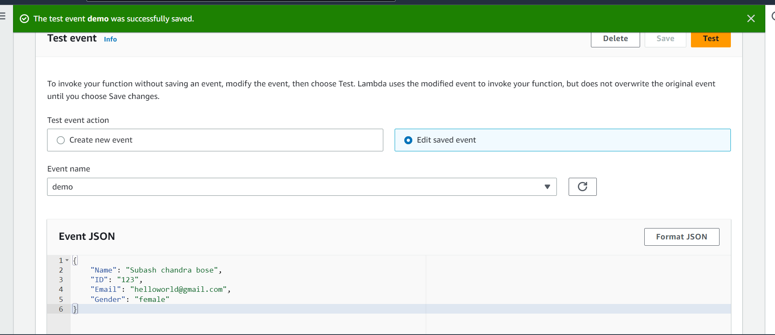

Copy arn

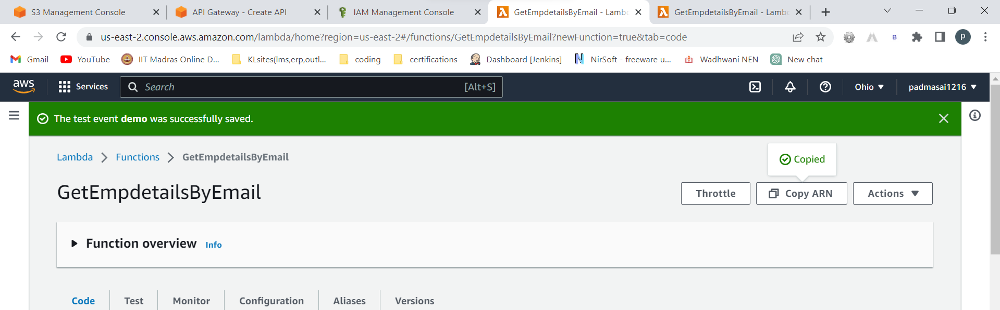

Click on getempdetailsbyemail (resource name)

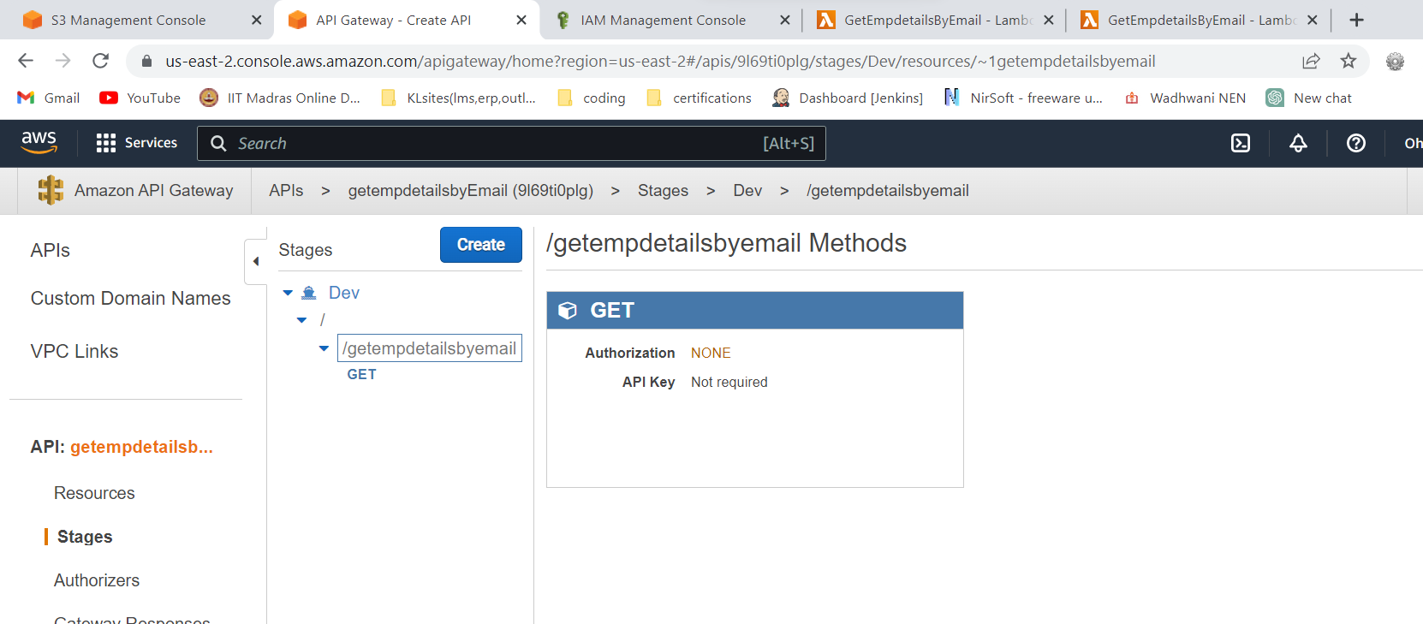

If your in stages … go to resources (imp point)

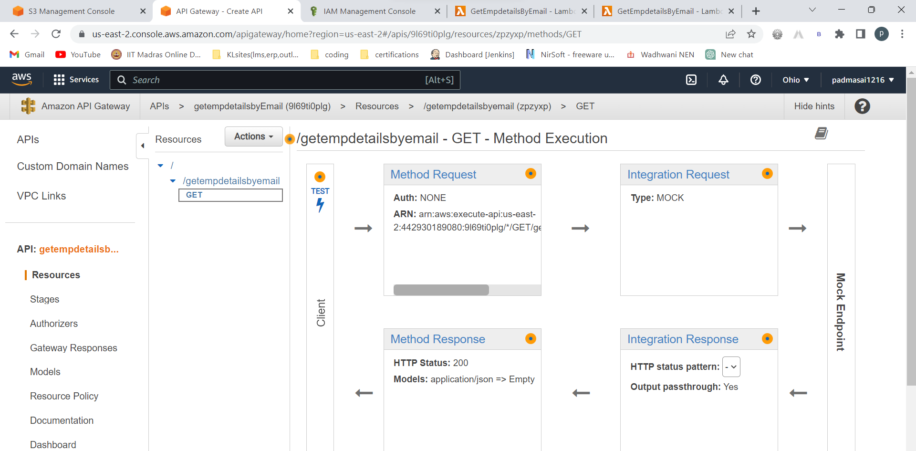

Integration response

Remobve the code in that generate template and save that again above blue save button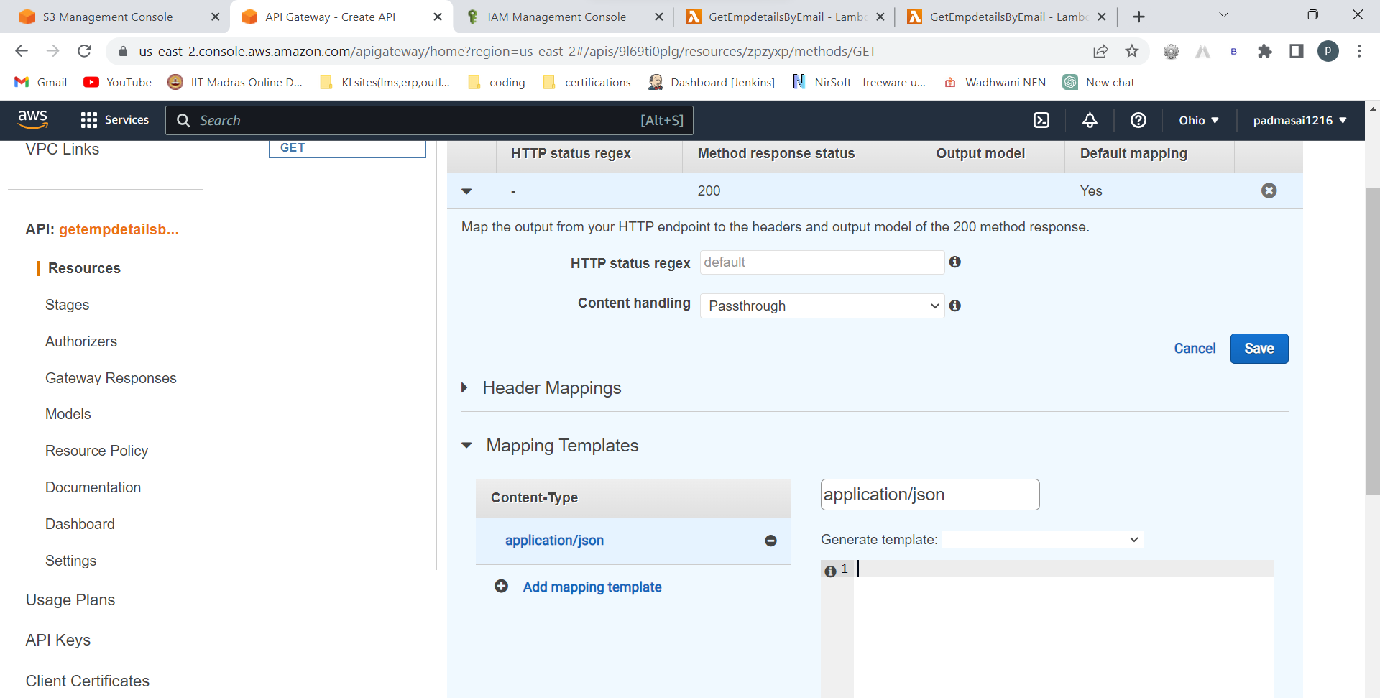

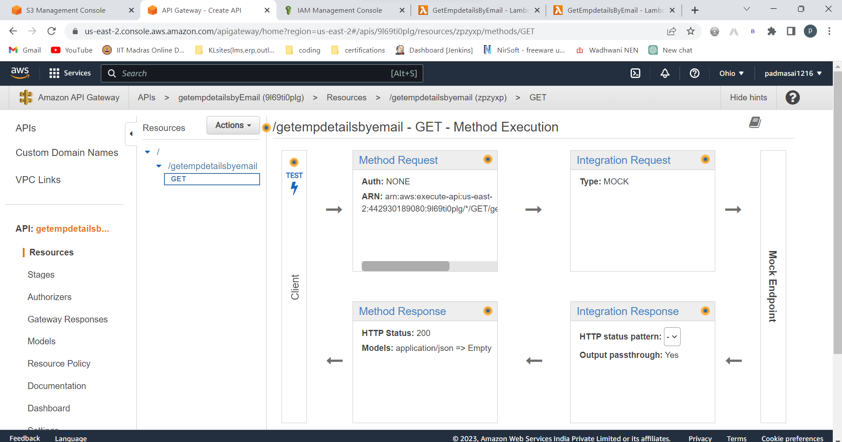

Go to integration request

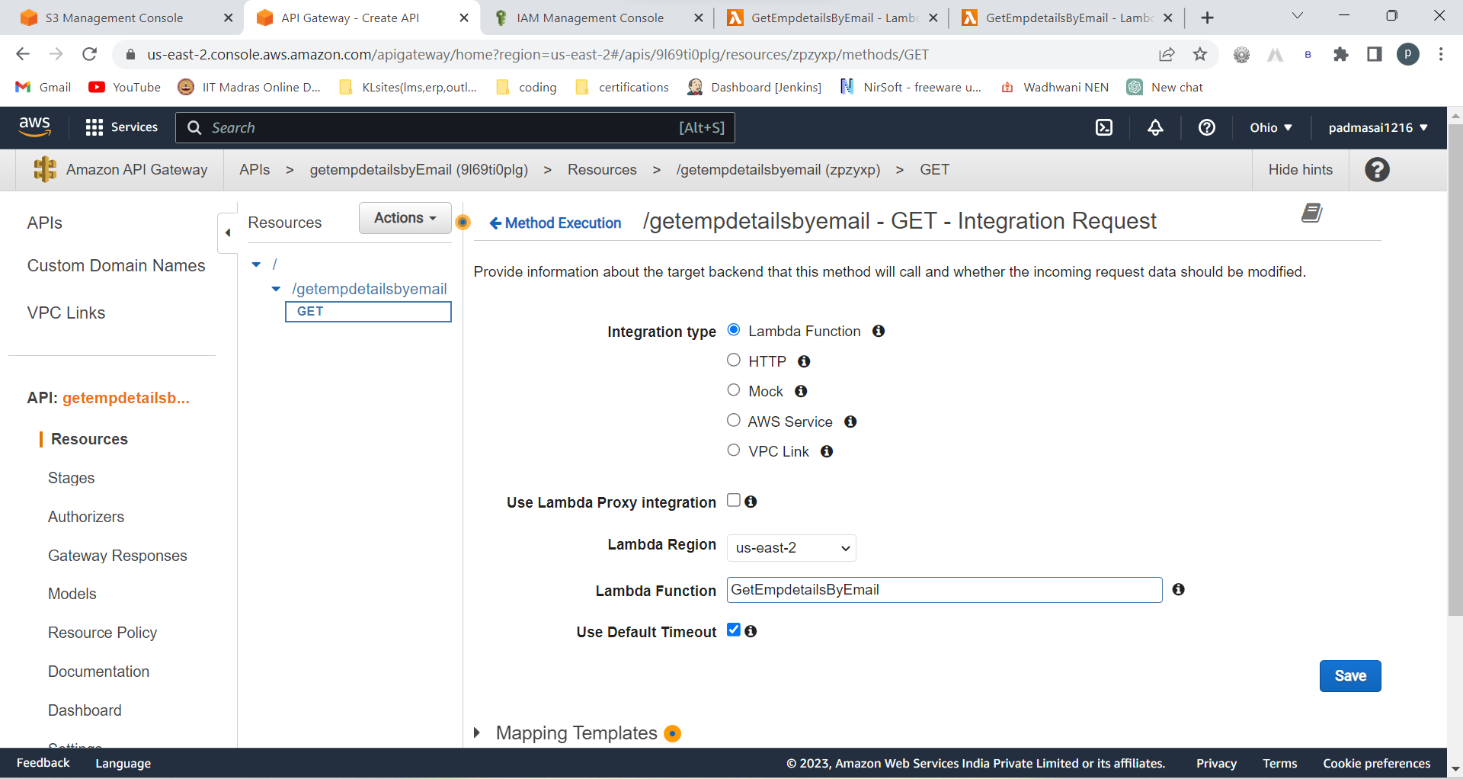

Save 🡪 ok 🡪 ok



Copy the arn for safe side:

**arn:aws:lambda:us-east-2:442930189080:function:GetEmpdetailsByEmail**

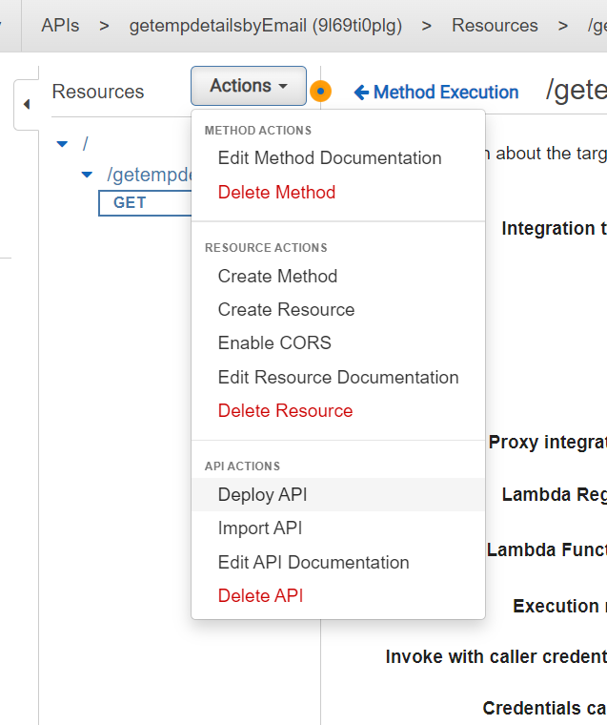

Deploy api

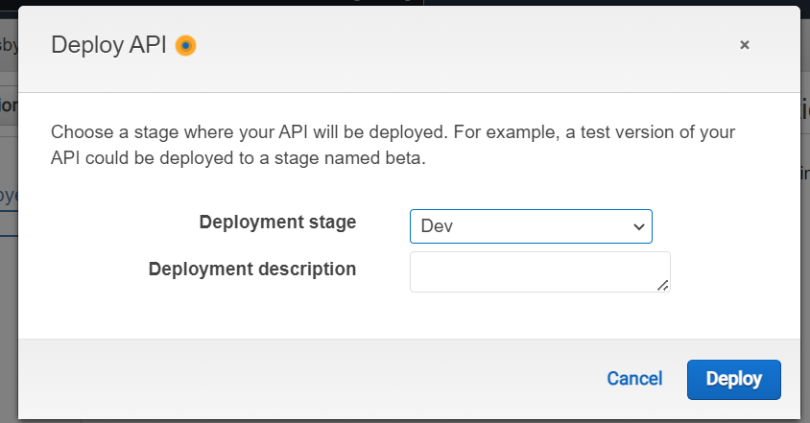

Deploy

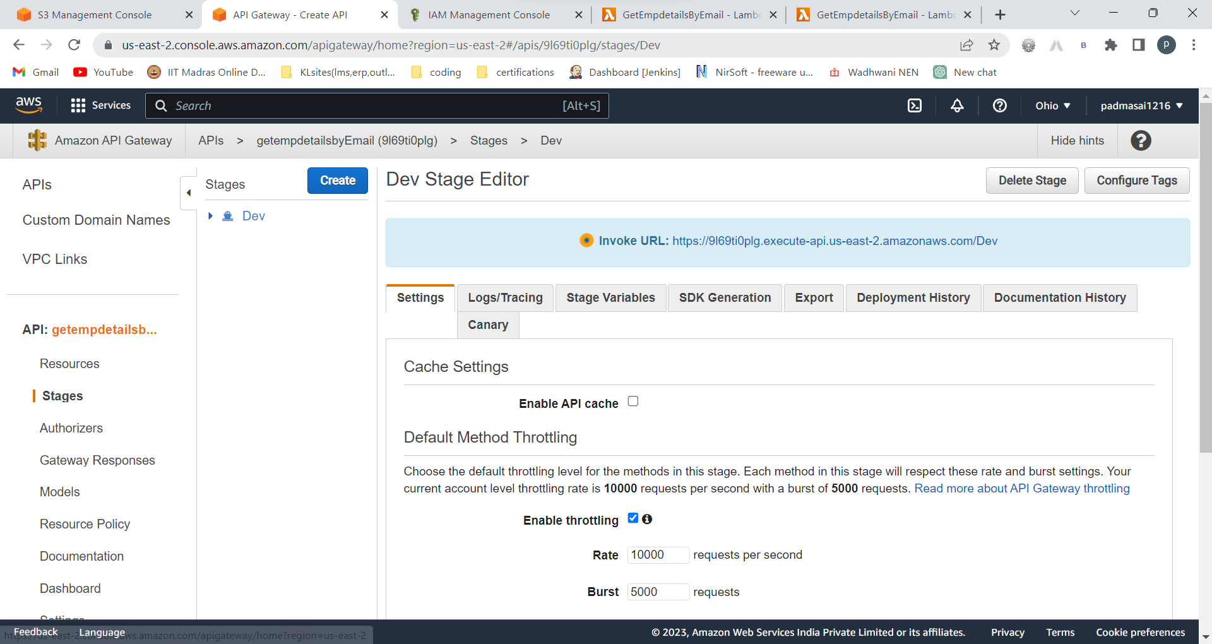

Copy paste the url/(resource name) in postman to check whther it is working or not

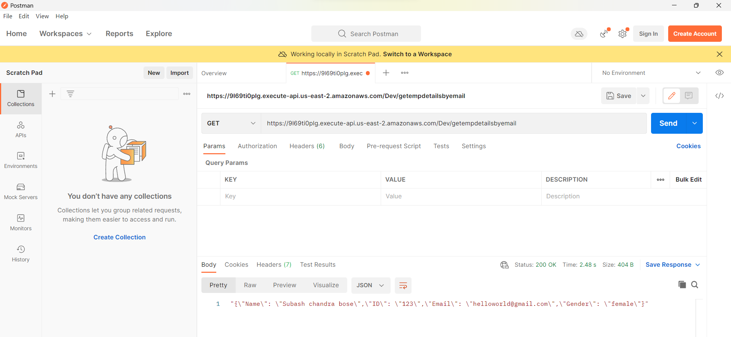

Output came success!!

Just checking lambda and api gateway is conneted or not

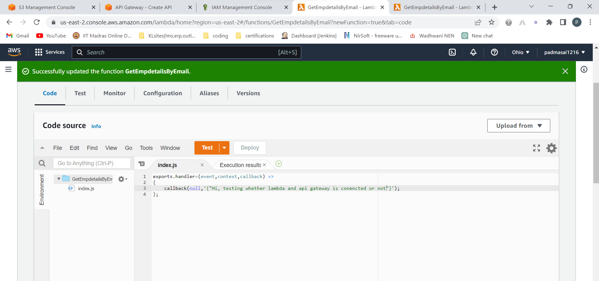

Just go to postman api and click on send

You will see updated output

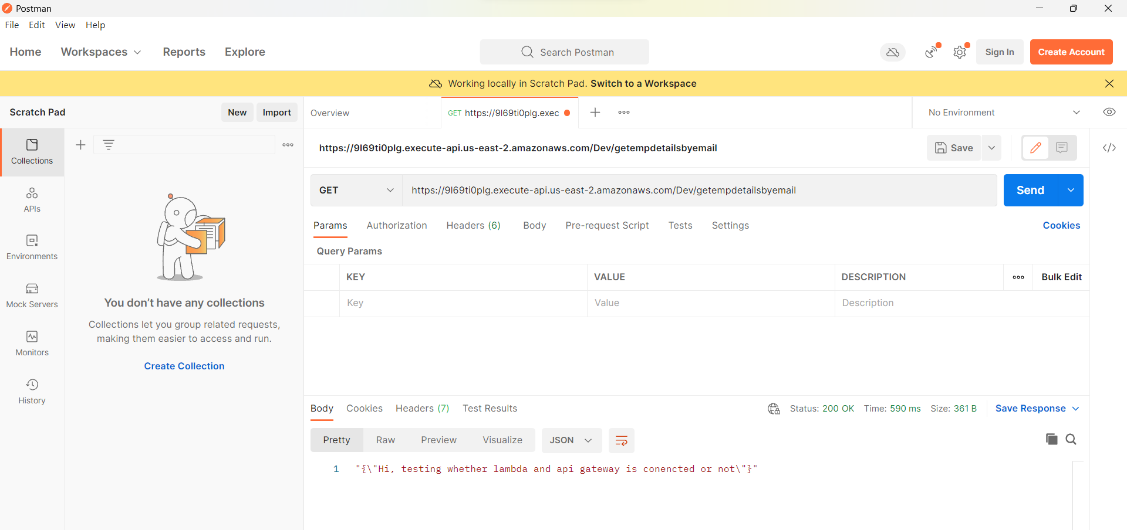

Perfect!!! (Lambda and API gateway are connected)

Creating a DynamoDB table

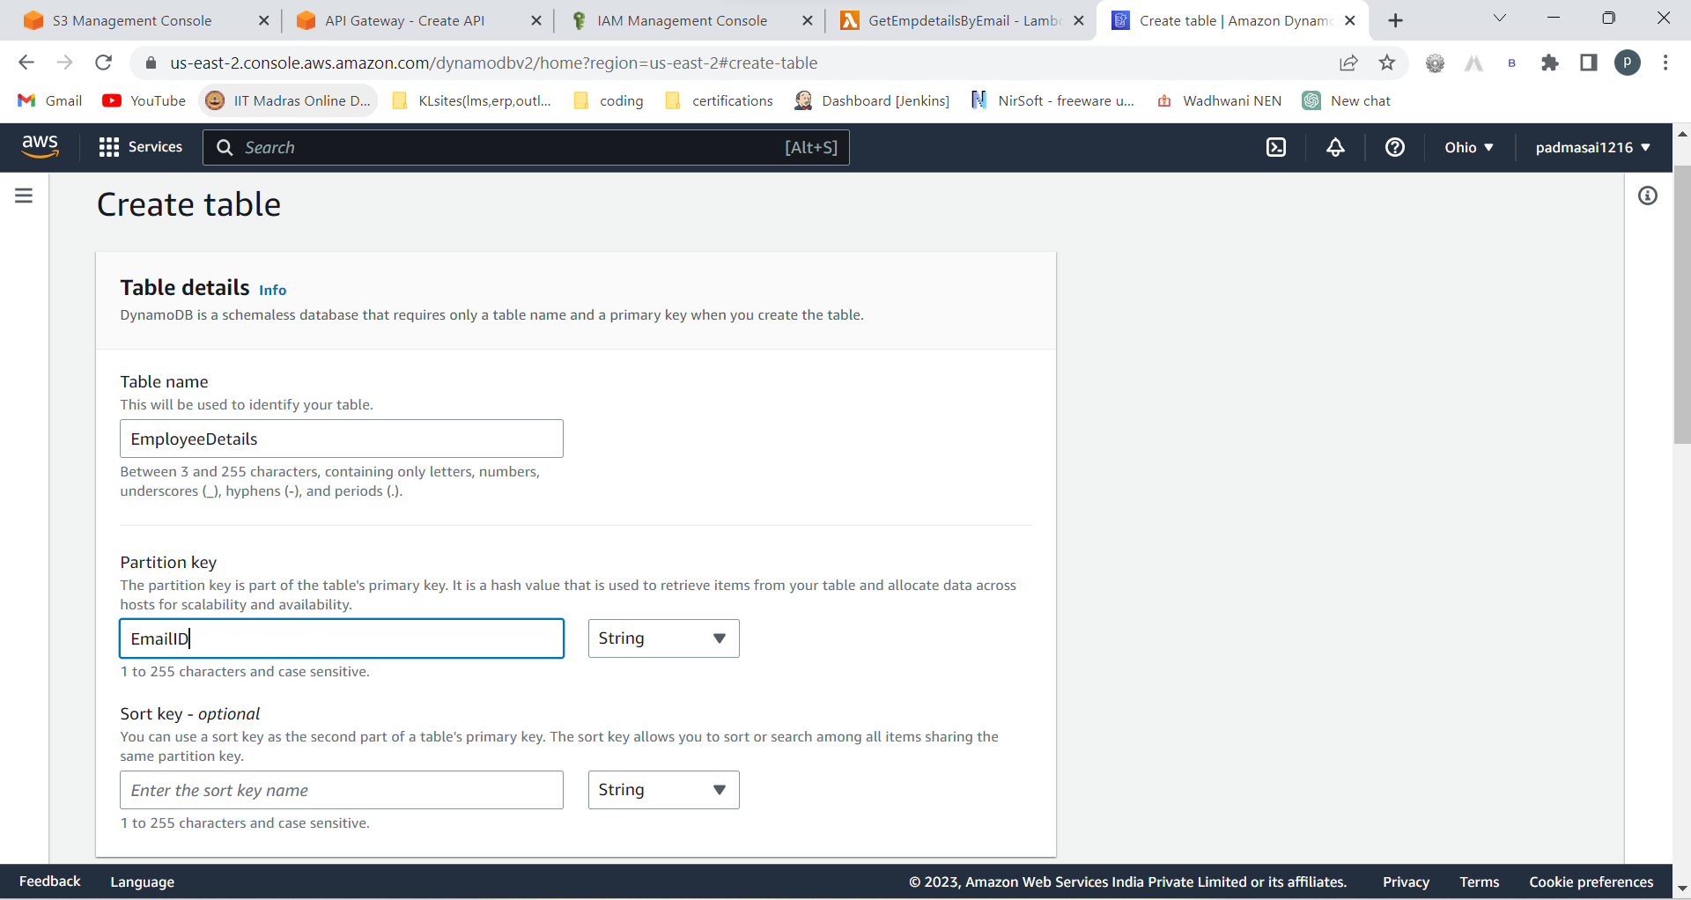

Create table

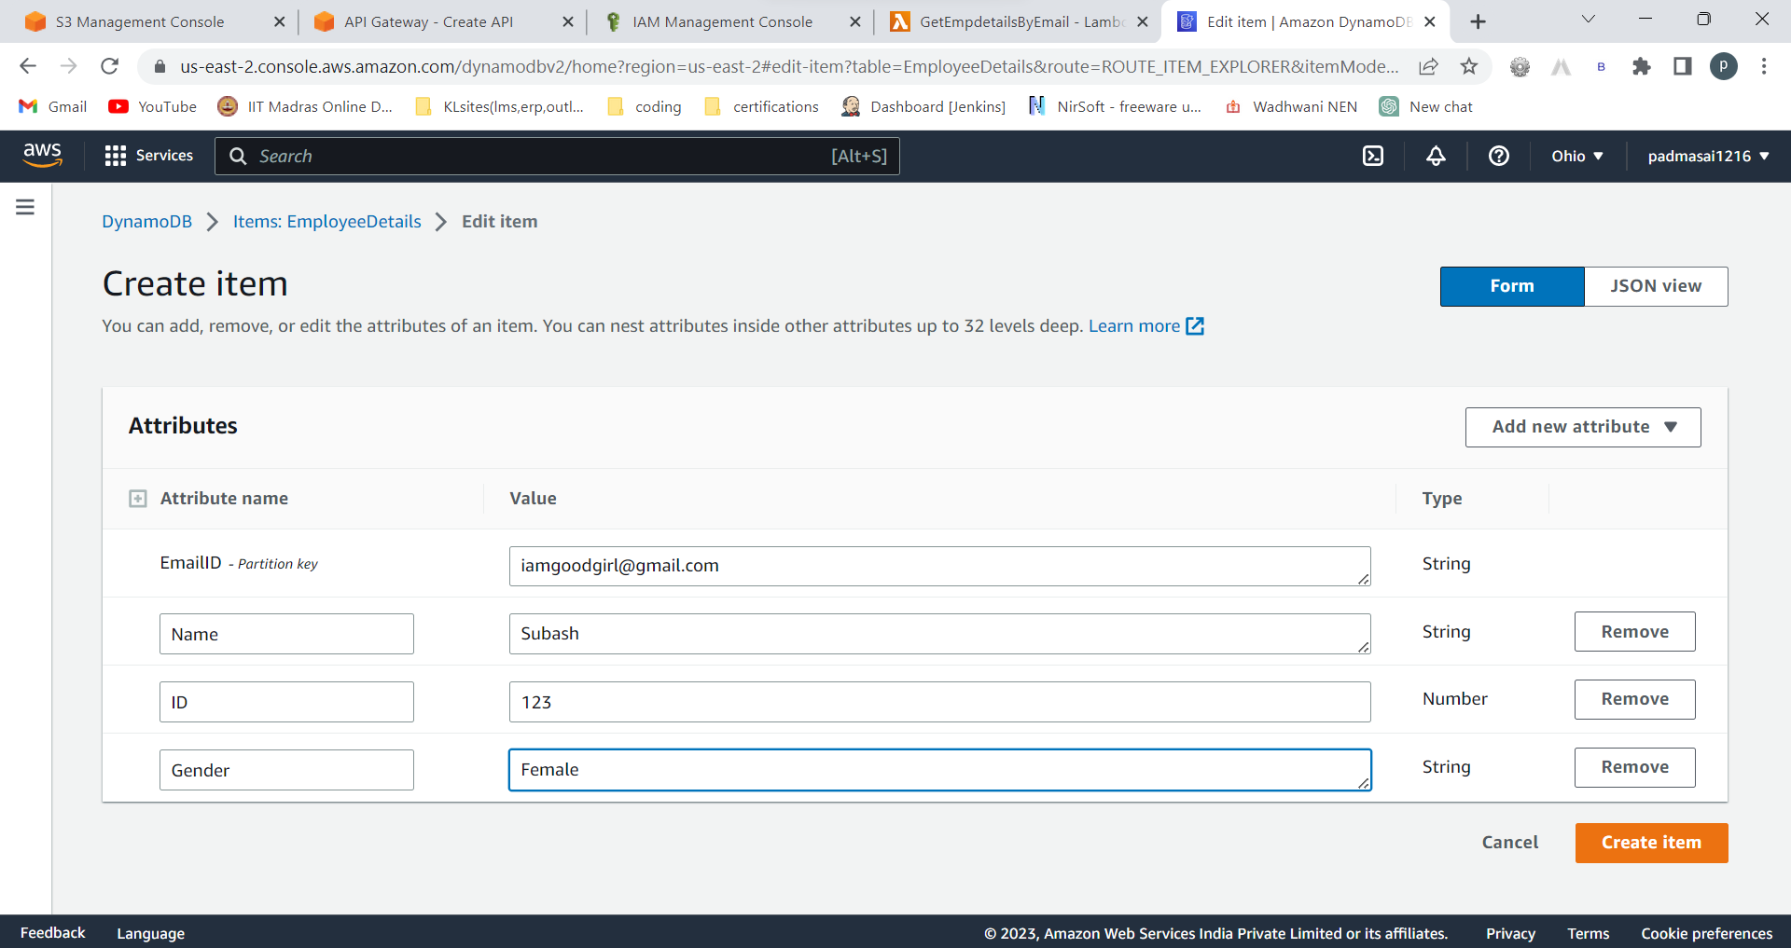

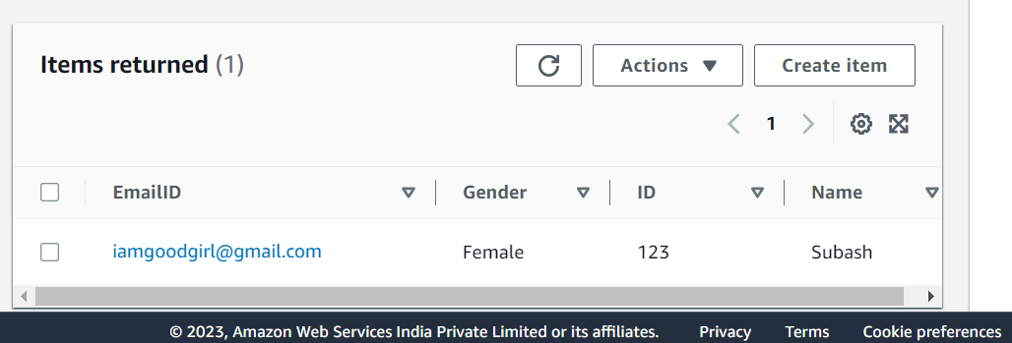

In lambda function change the code to:

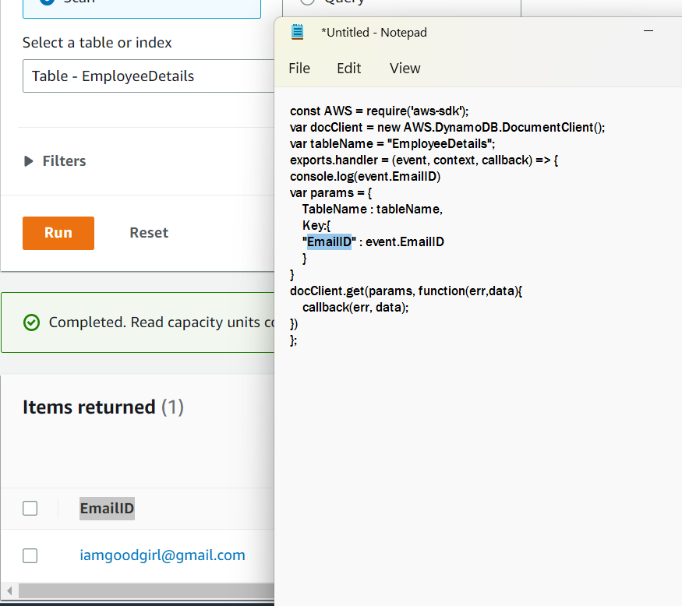

That highlighted EmailID must be same

In the above code , so many semi colons are missing:

Exact code:

const AWS = require('aws-sdk');

var docClient = new AWS.DynamoDB.DocumentClient();

var tableName = "EmployeeDetails";

exports.handler = (event, context, callback) => {

console.log(event.EmailID);

var params = {

TableName : tableName,

Key:{

"EmailID" : event.EmailID

}

};

docClient.get(params, function(err,data){

callback(err, data);

});

};

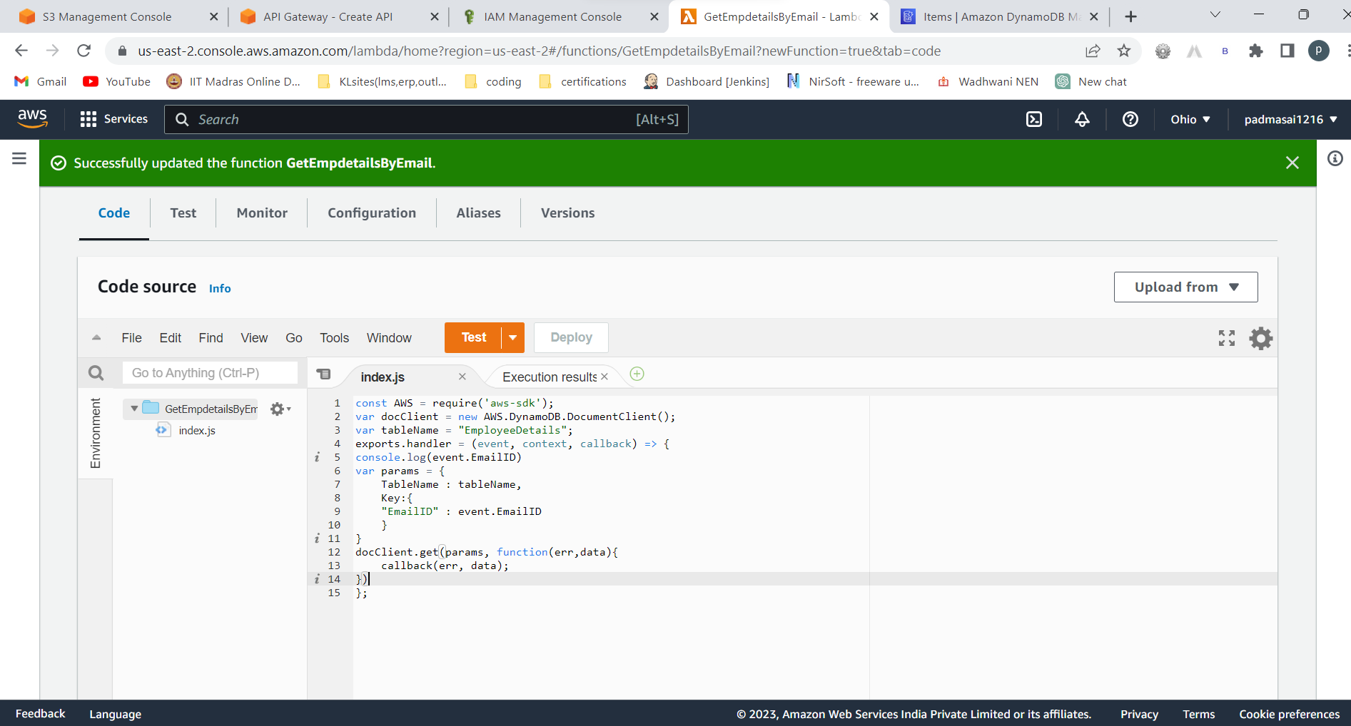

Give the email of the record which you want to fetch the details

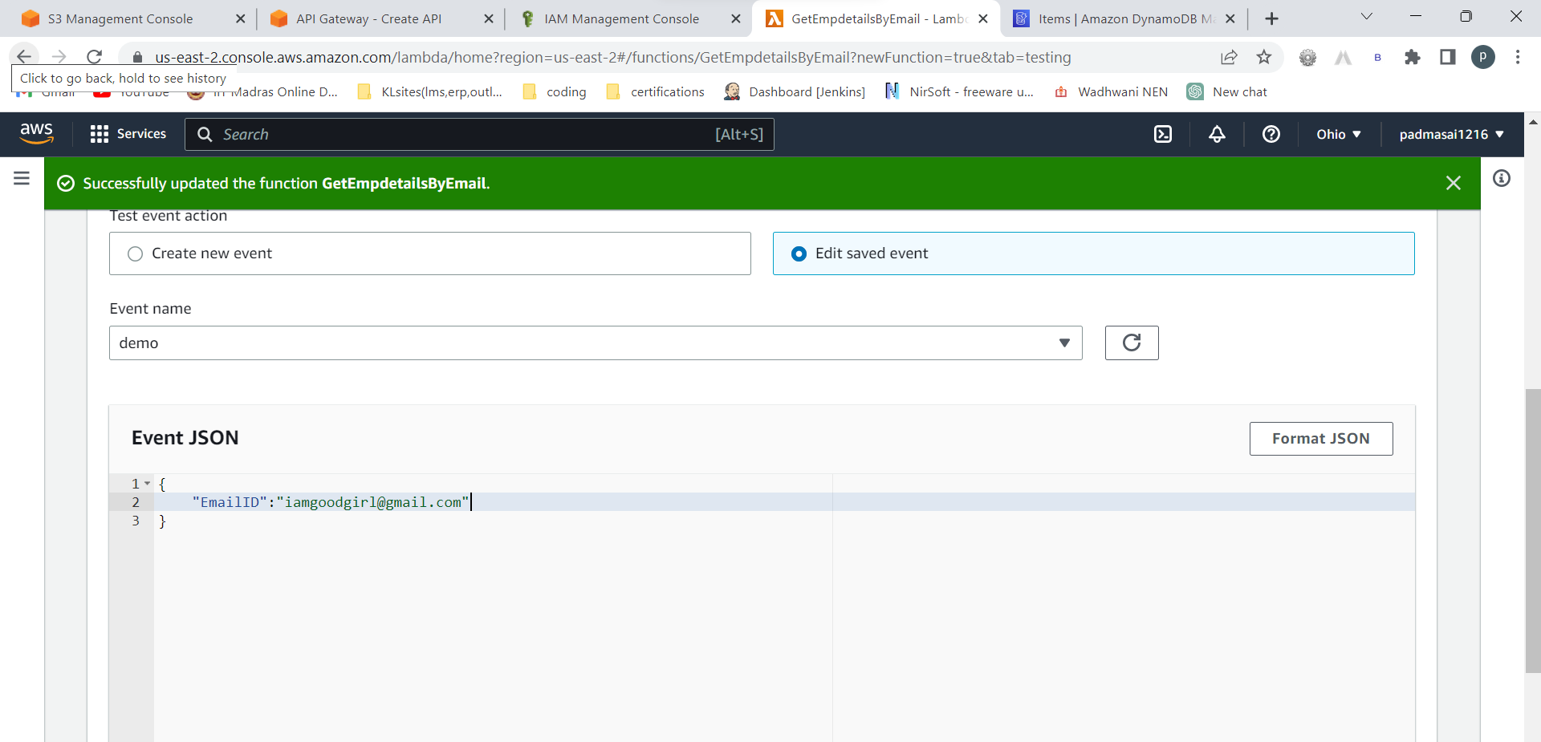

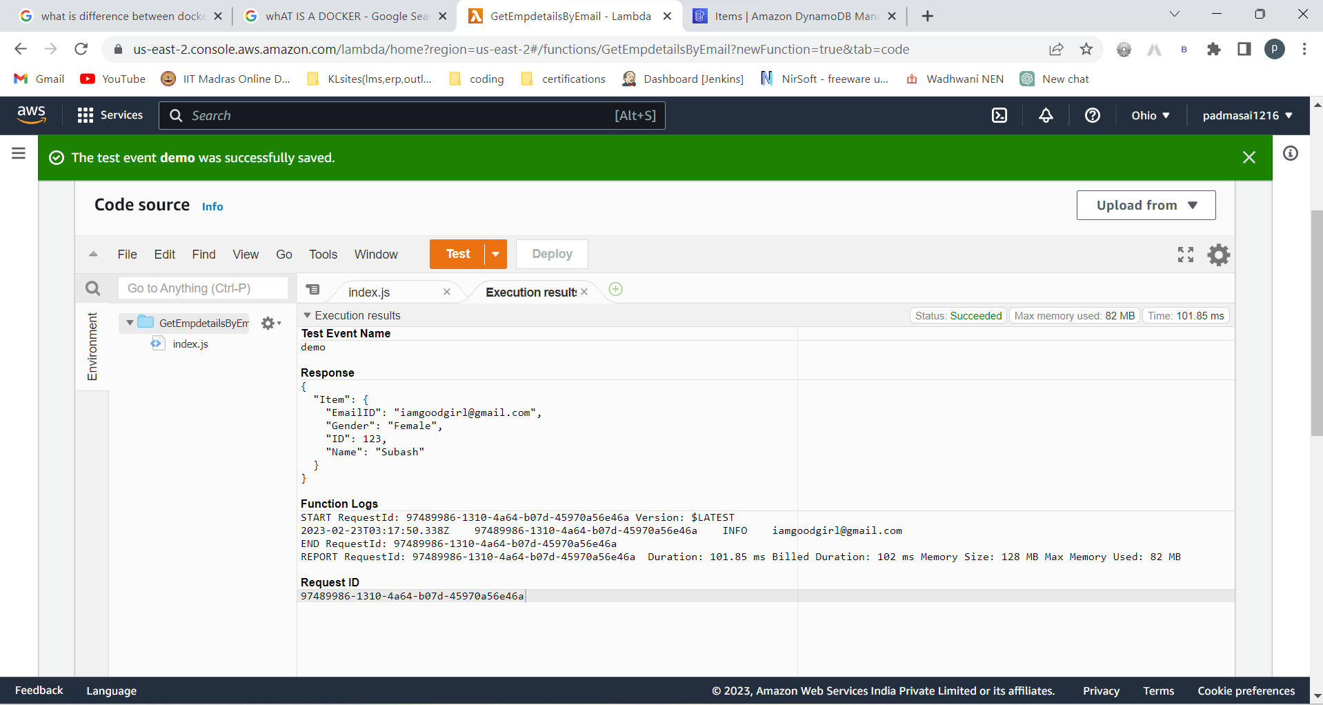

It fetched data from dynamodb.

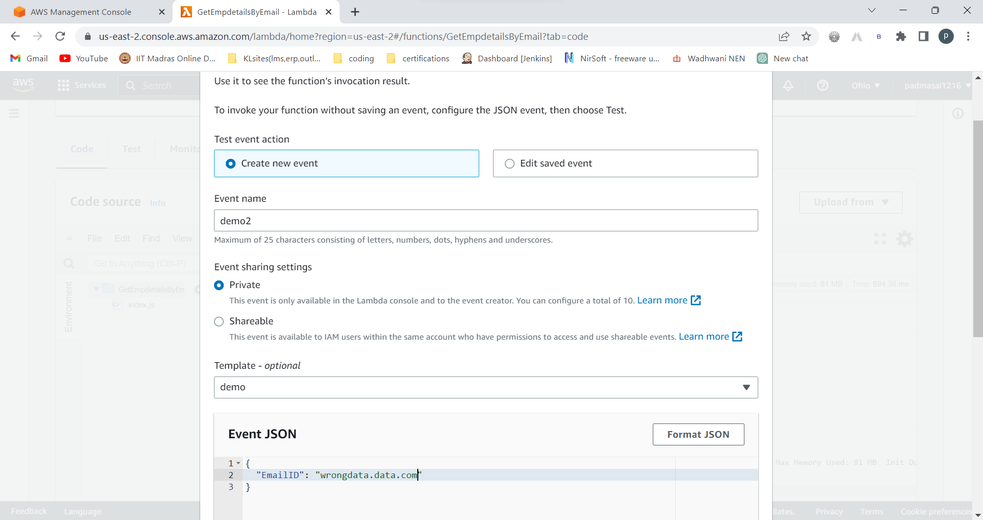

If we give wrong data

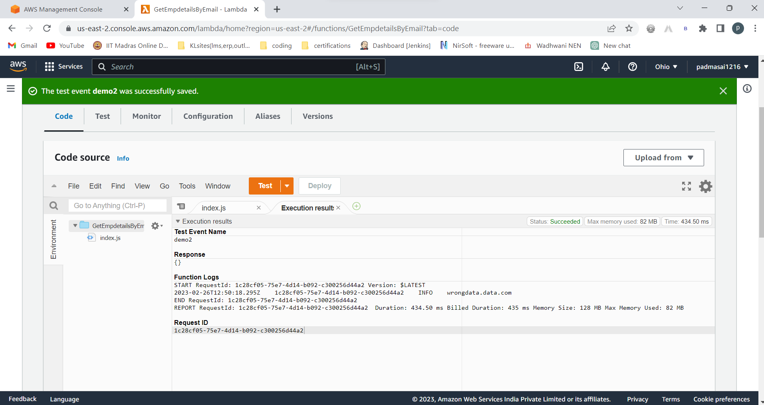

It returned nothing

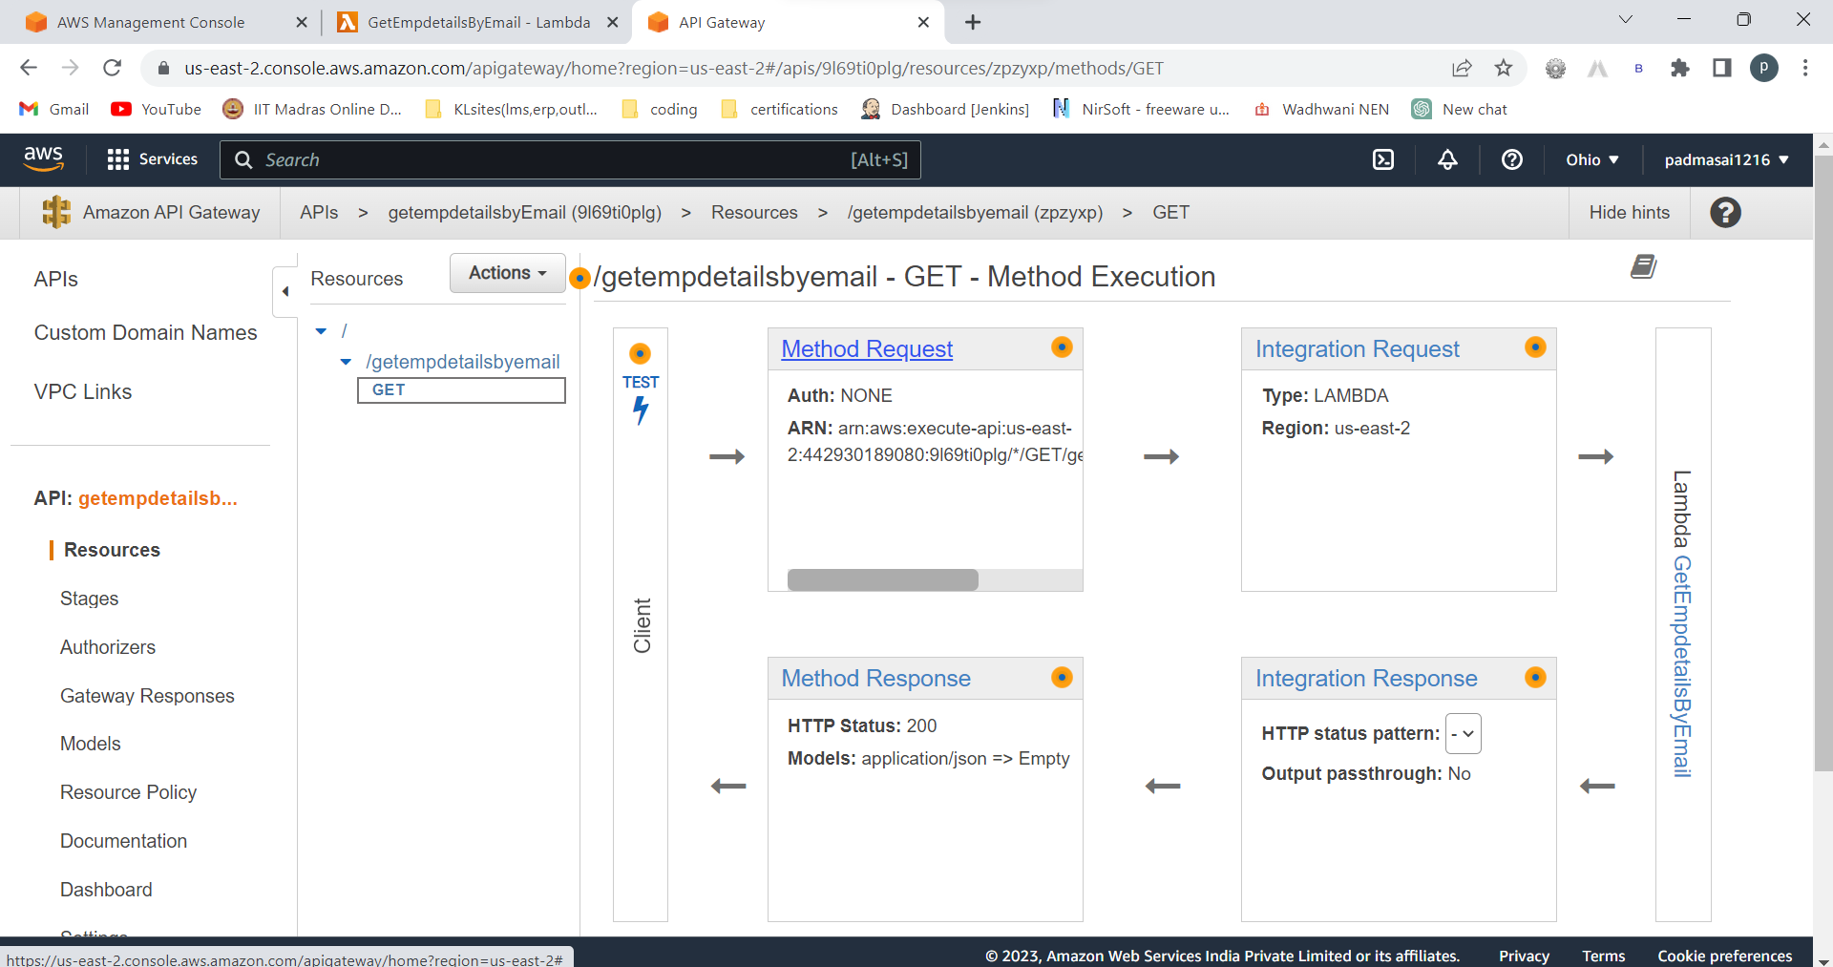

Go to method request

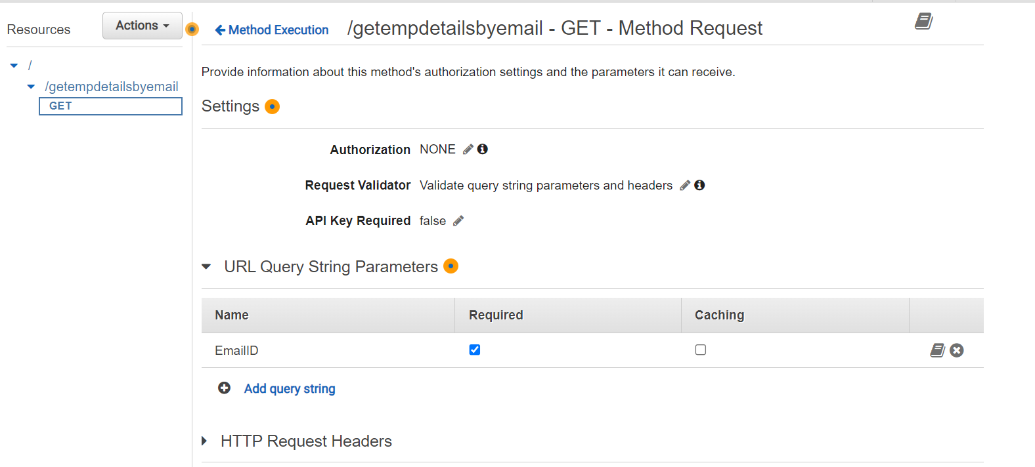

Request validator , add query string , check to required

Come back

Go to integration request

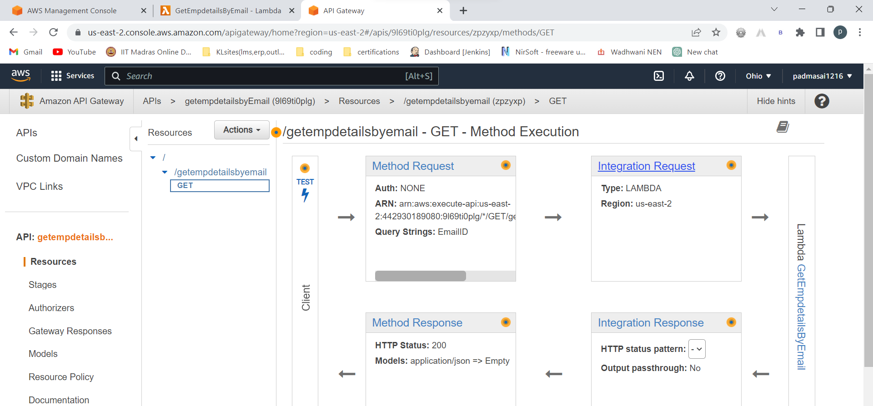

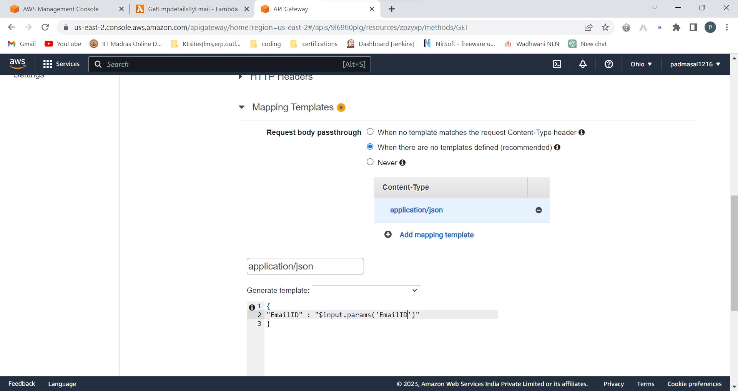

Click on save

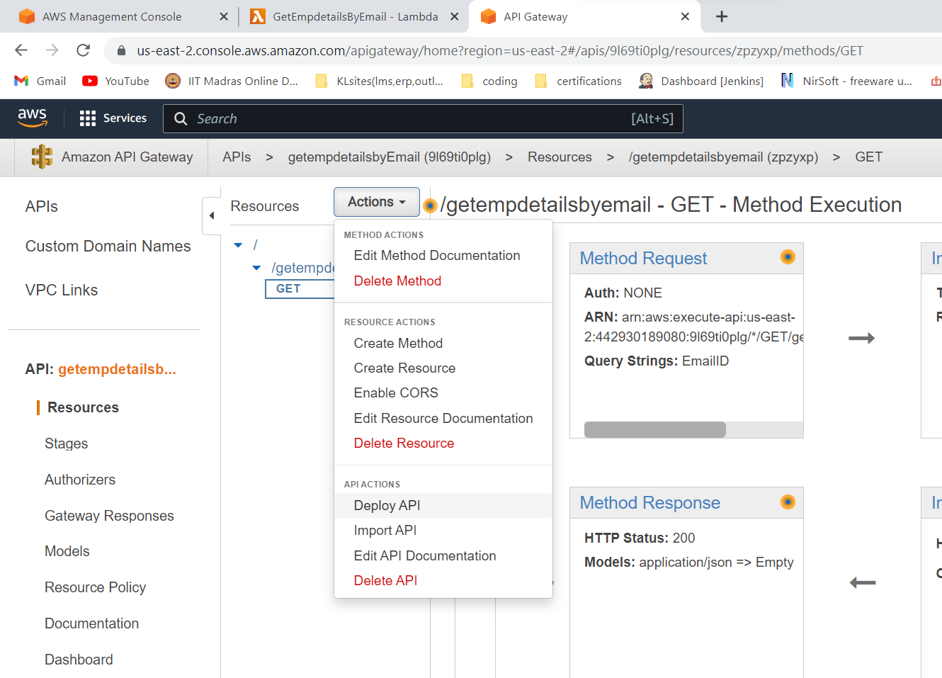

Again re-deploy the API

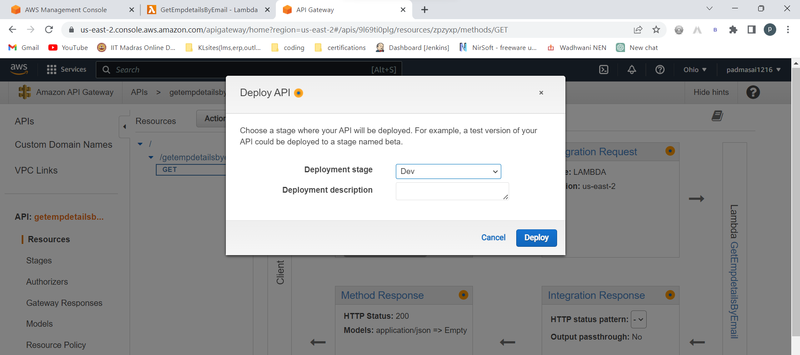

Click on deploy

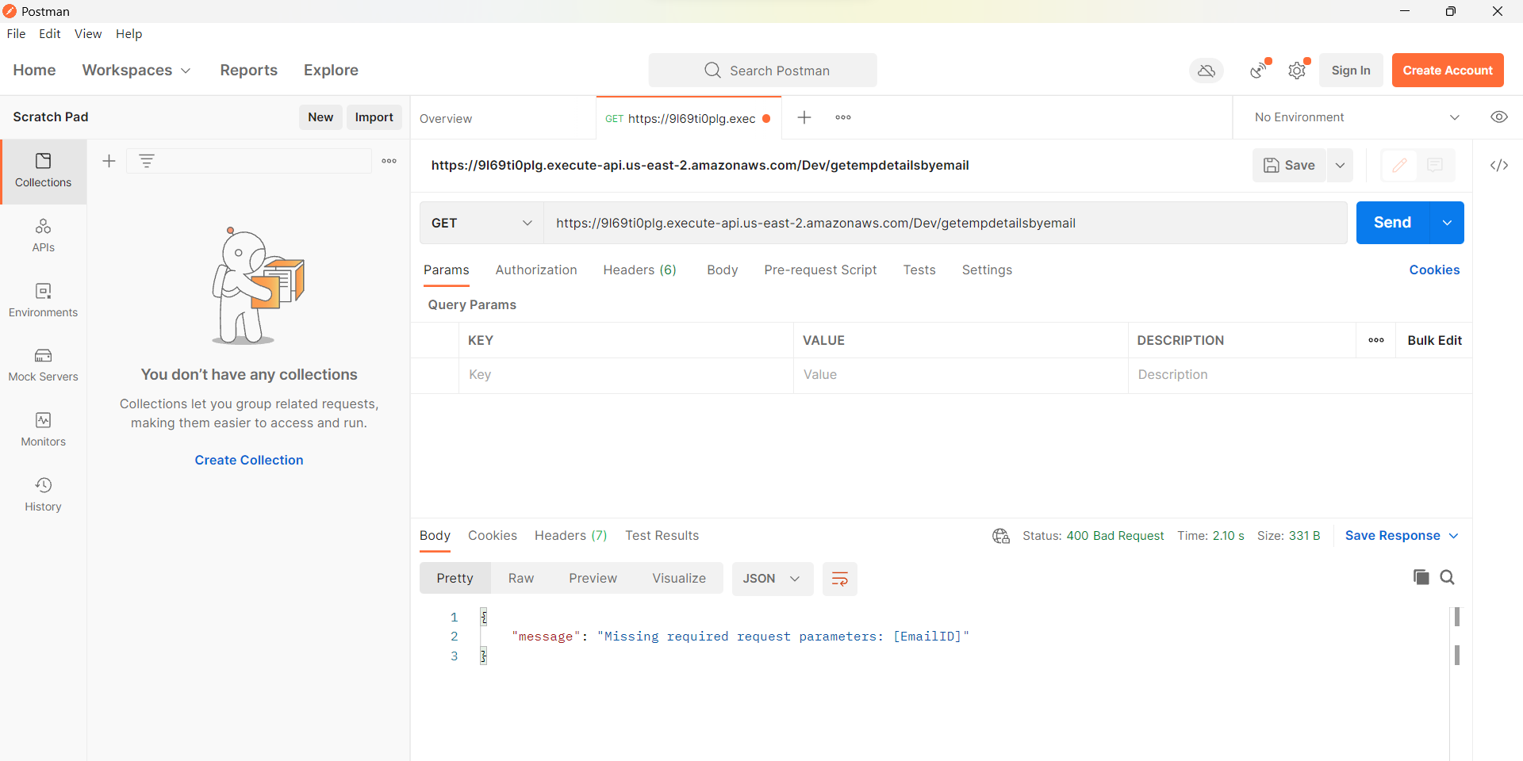

Check the invoke url in postman adding /getempdetailsbyemail

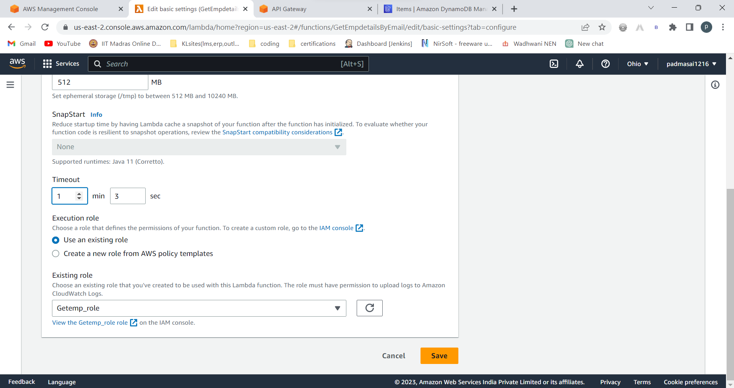

Change time out in lambda configurations to above 1min

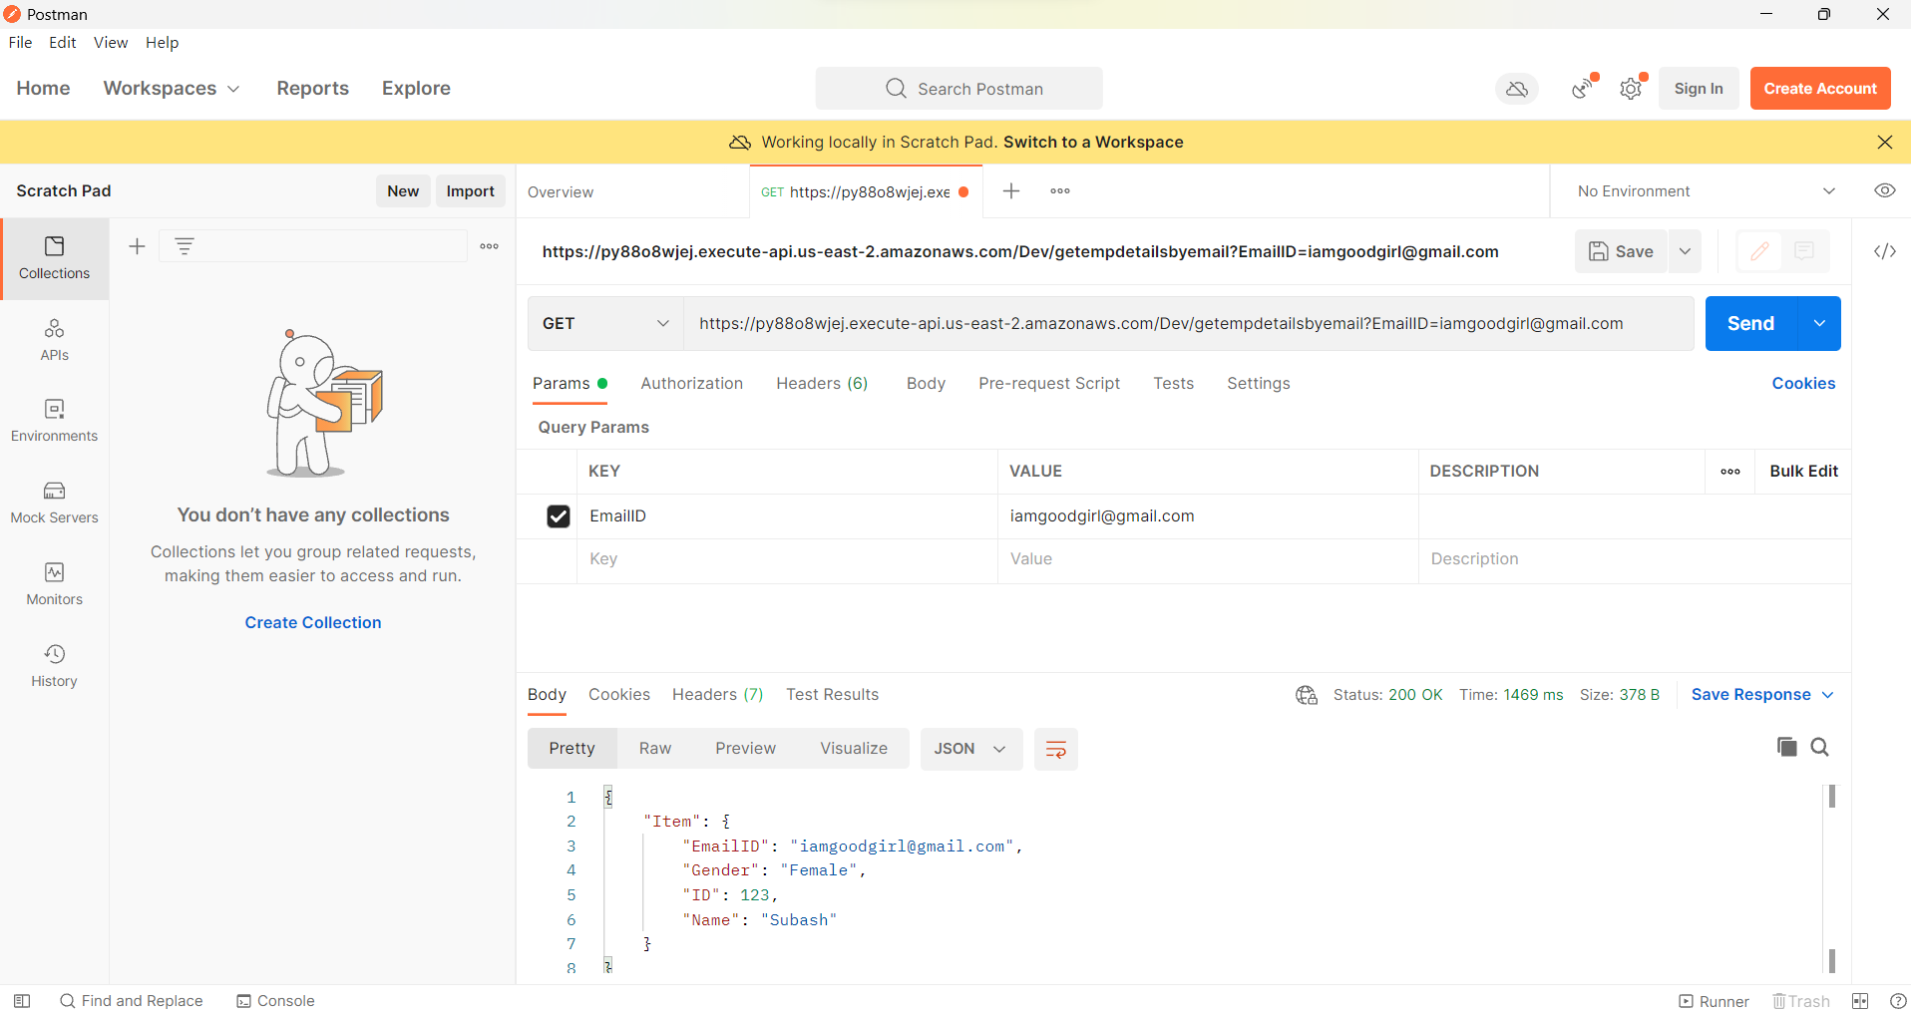

If you get internal server error..delete the API and give all connections again

You will get output:



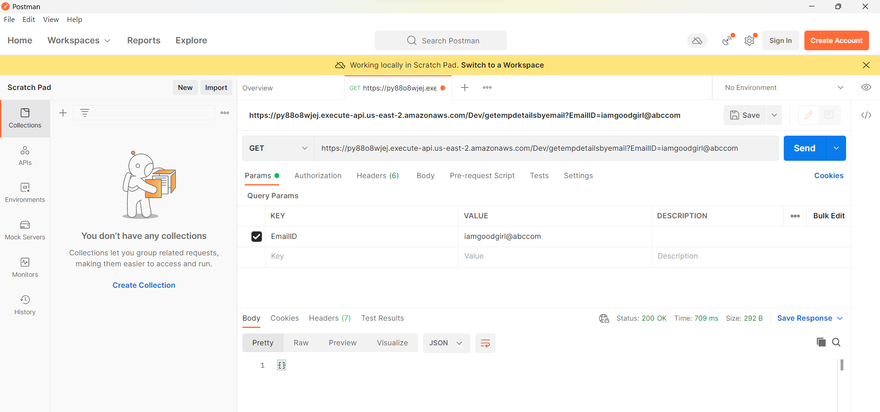

When we give wrong output , output should be nothing

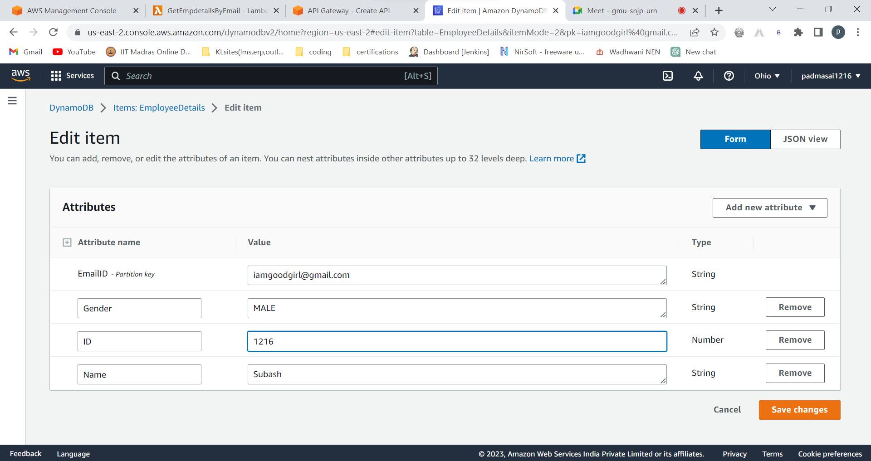

Edit the item values in dynamodb

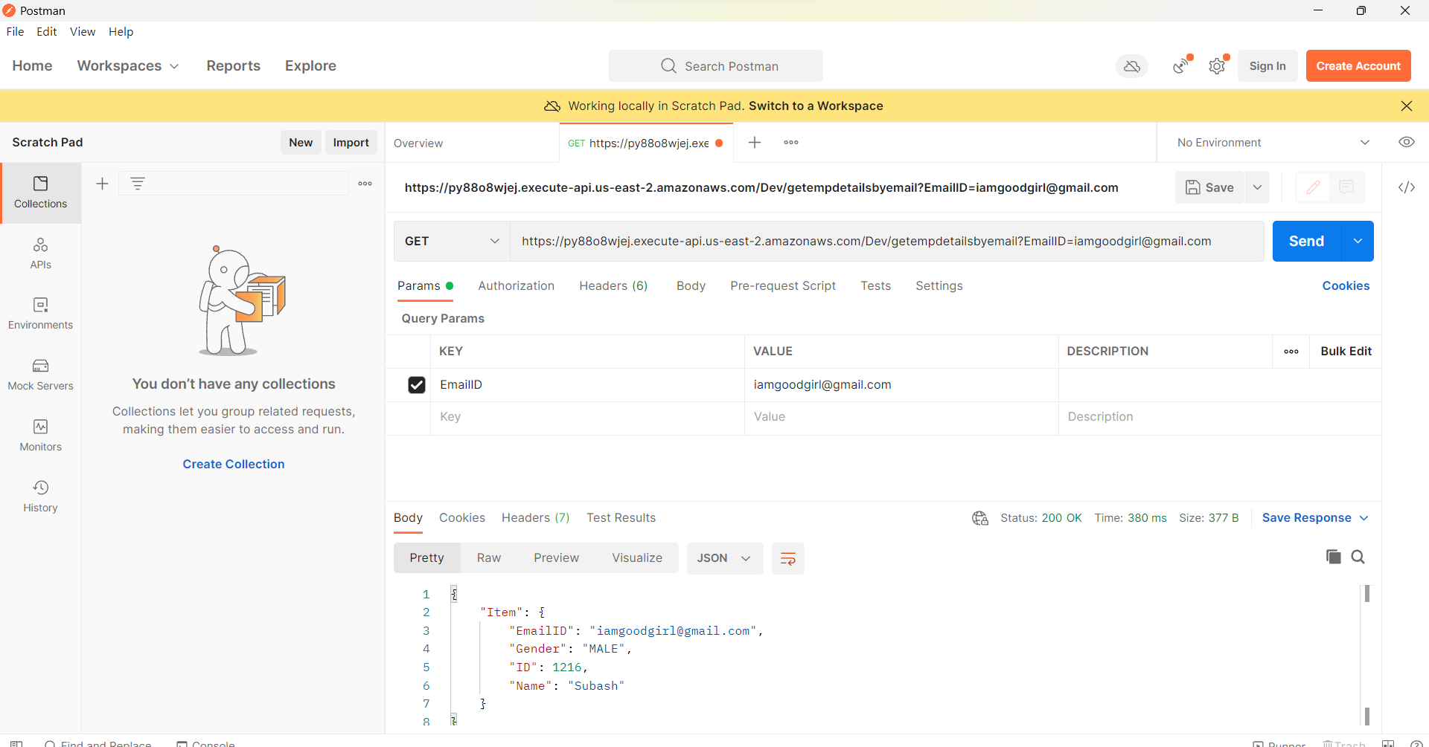

We got updated values as output.HURRAY!!!

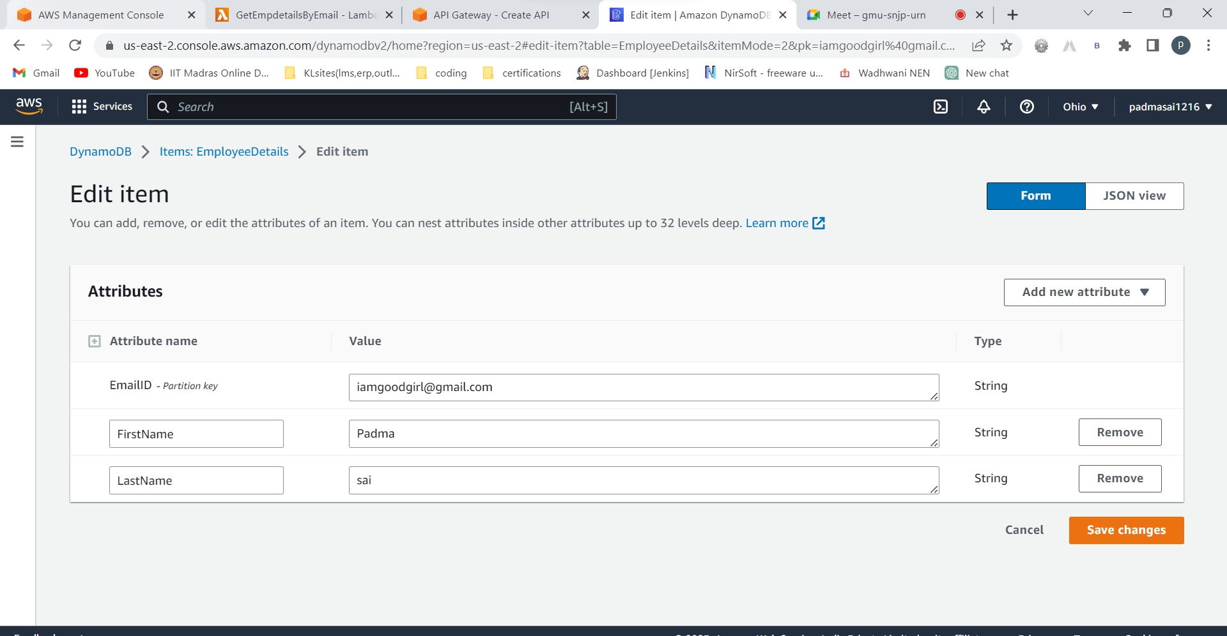

I am changing attributes to match with index.html code.. we can have attributes of our wish but we have to do changes for attribtes in index.html code also,

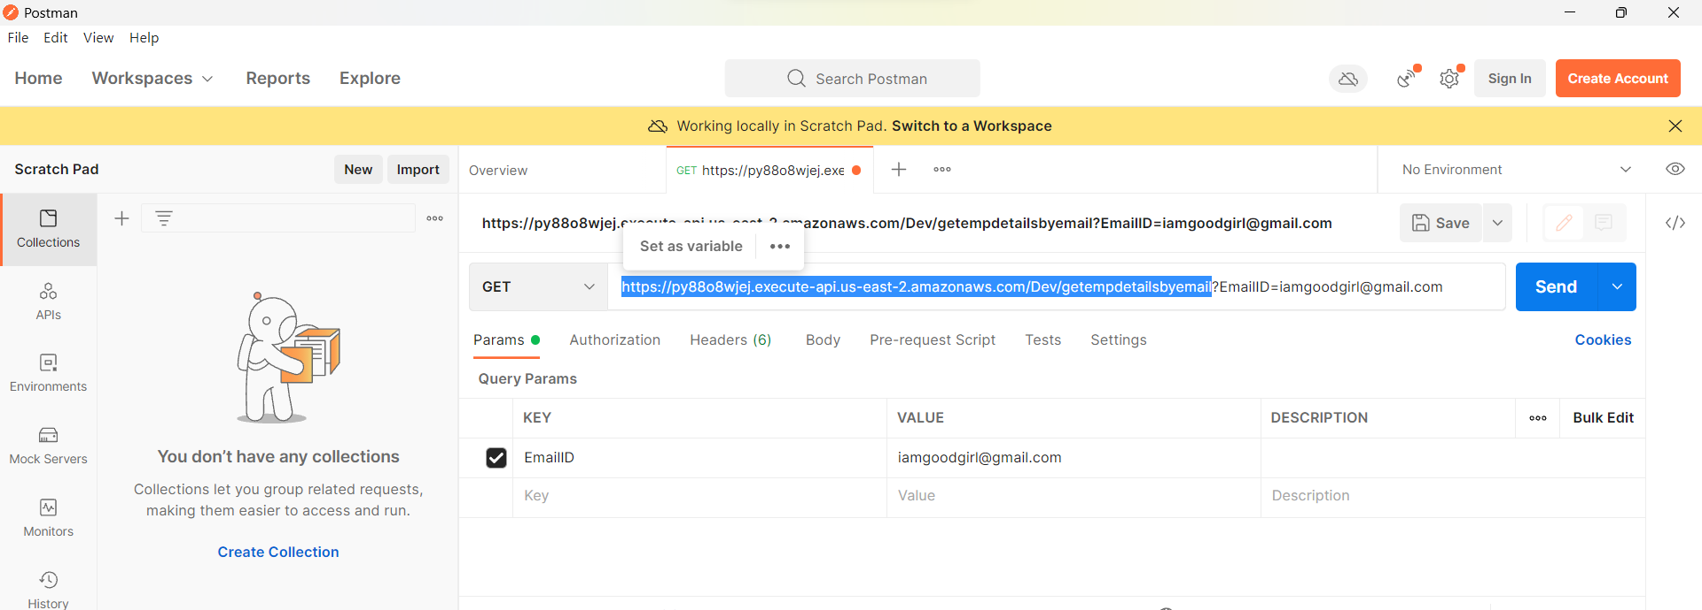

Copy this url

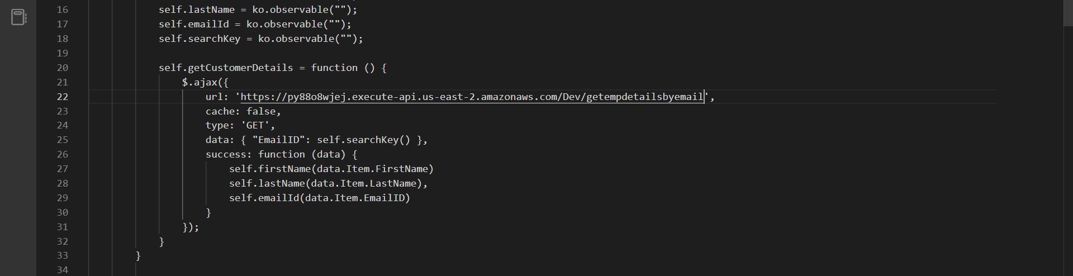

Paste that here

Go tot API gateway 🡪

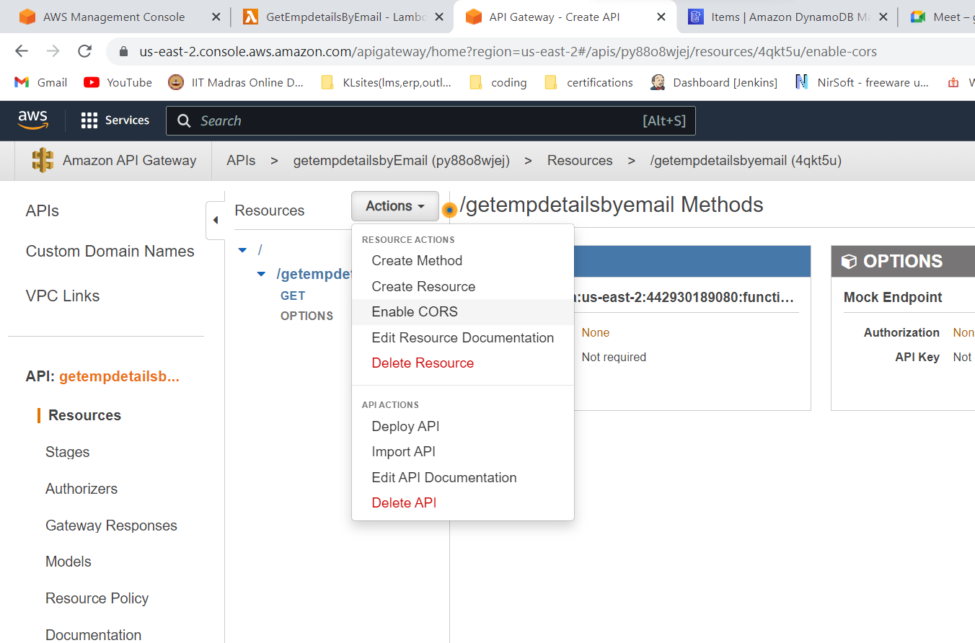

Enable CORS

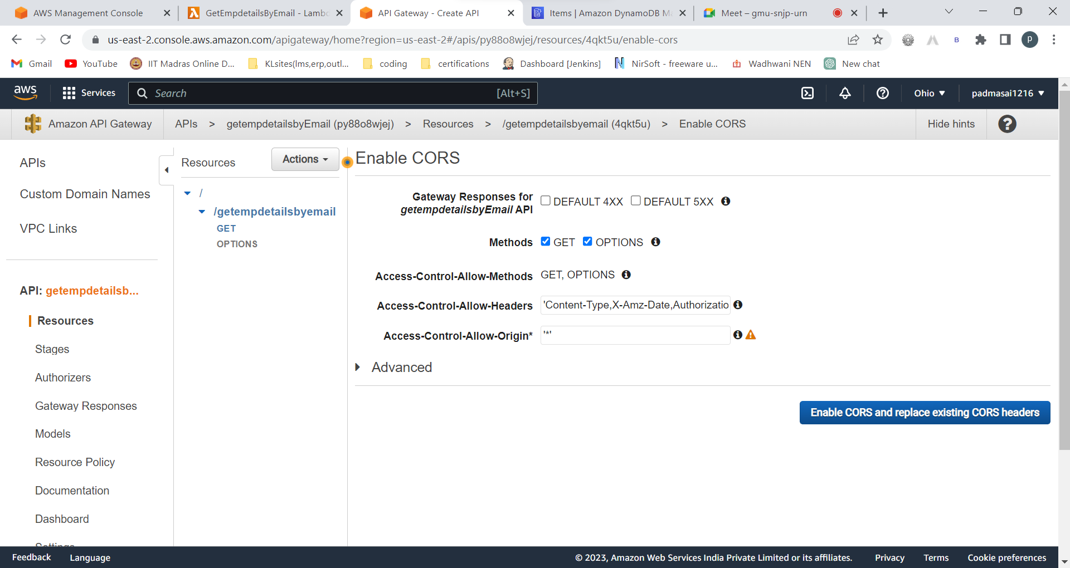

Click that blue button

Yes replace

1.store index.html in s3­­­­

CREATING A BUCKET:

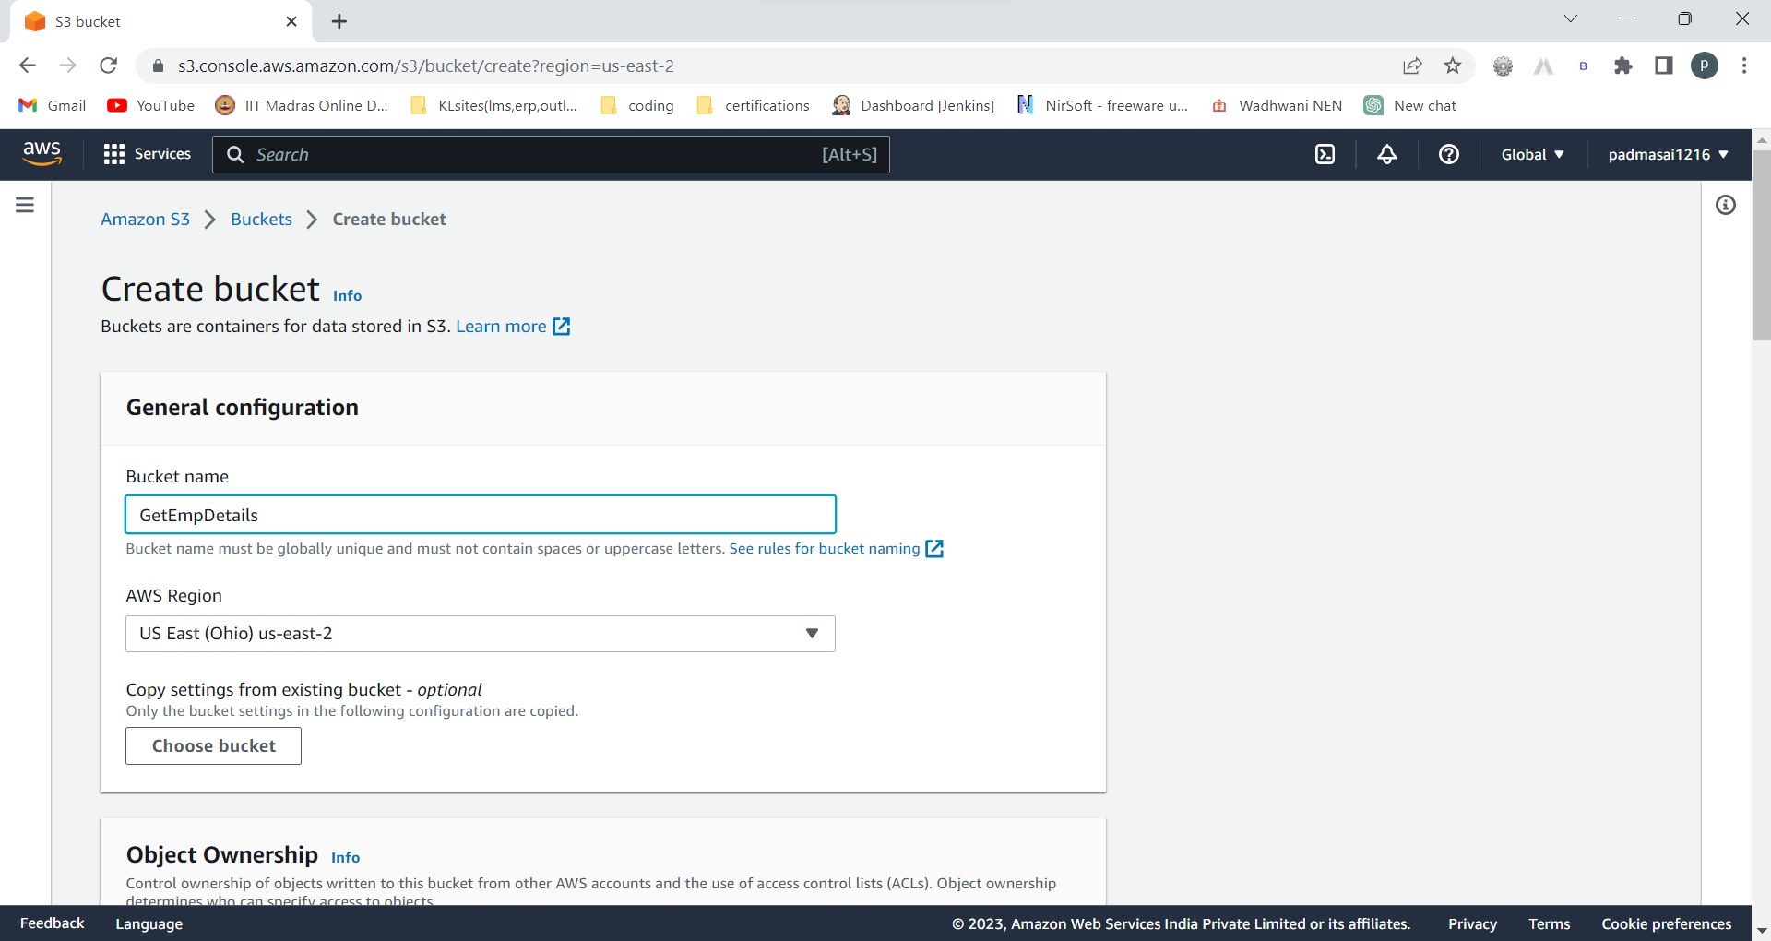

Name is changed to getempdetails

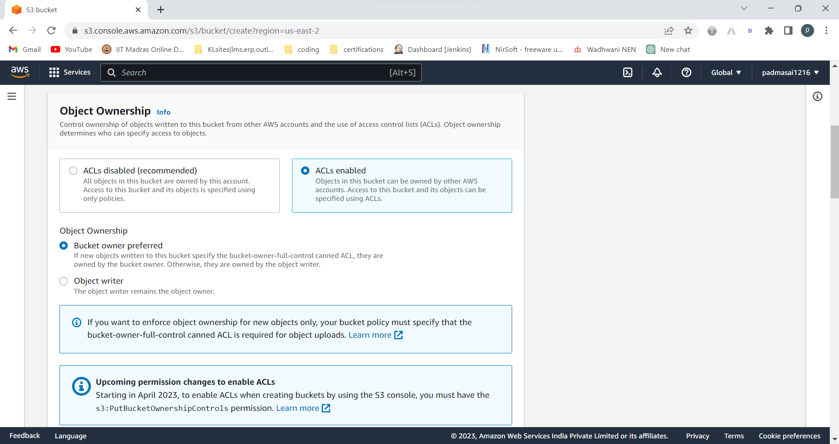

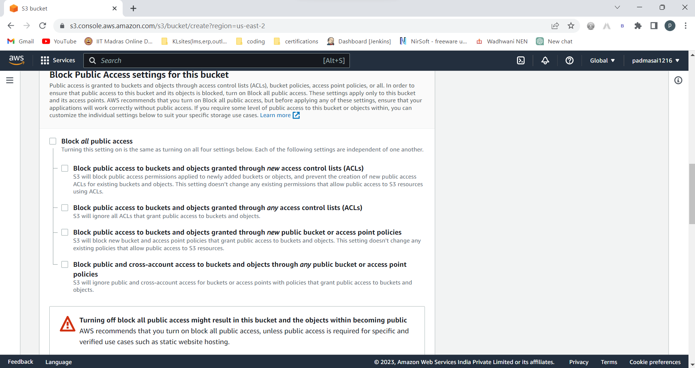

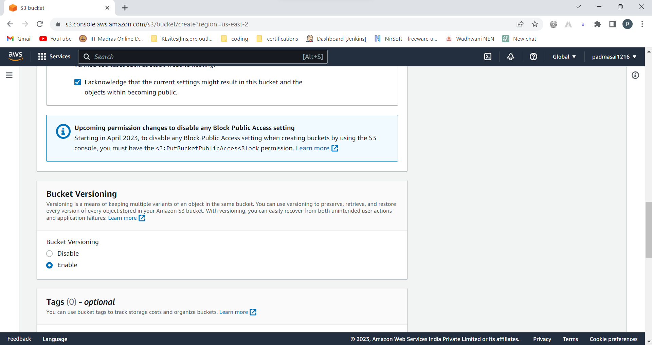

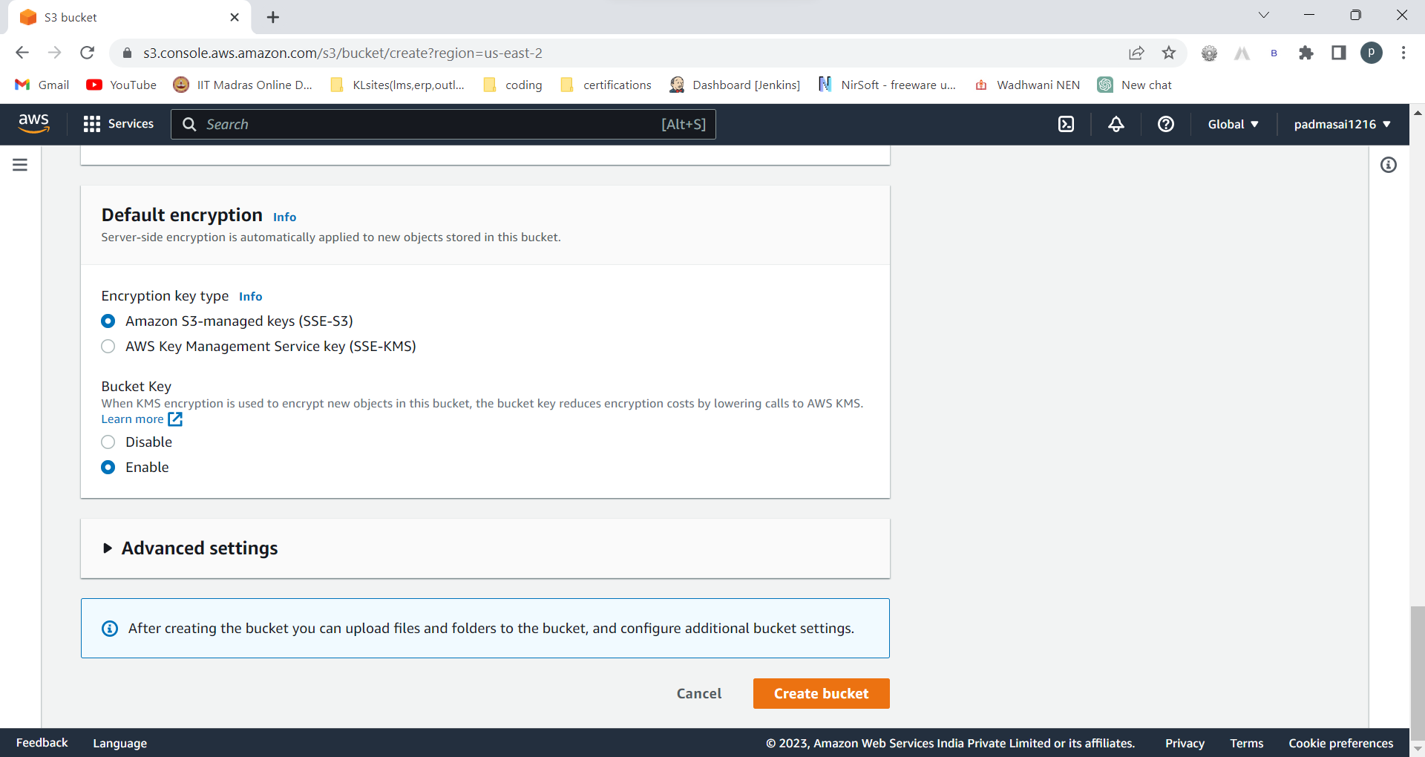

Enable static web hosting in properties and upload these 3 files

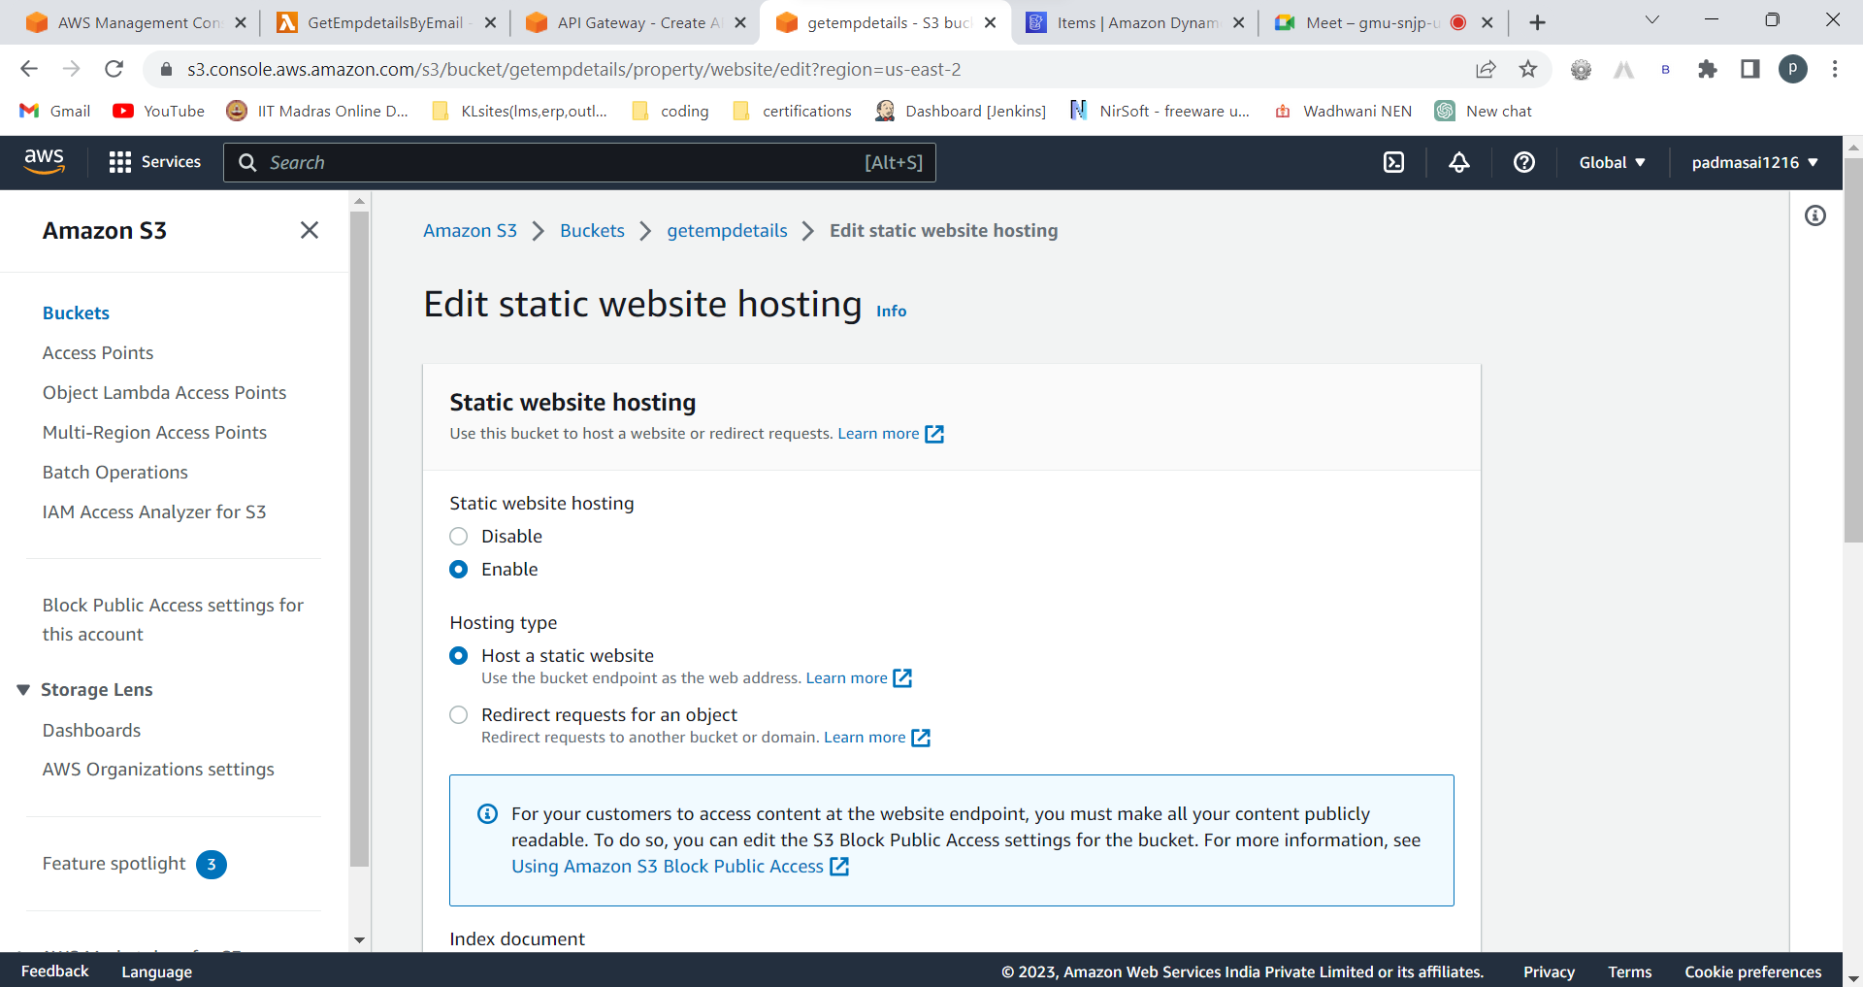

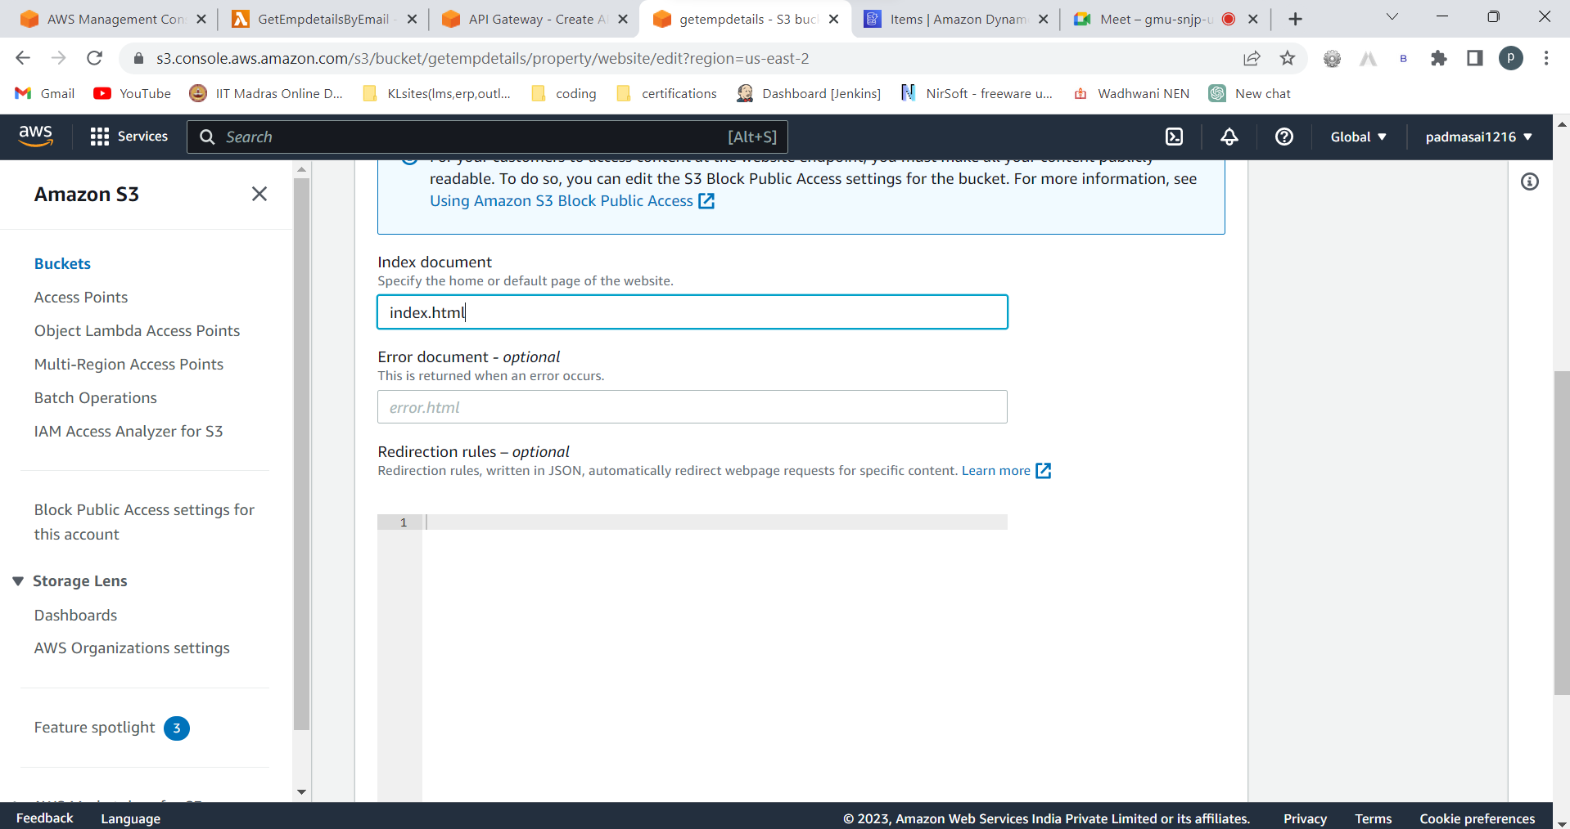

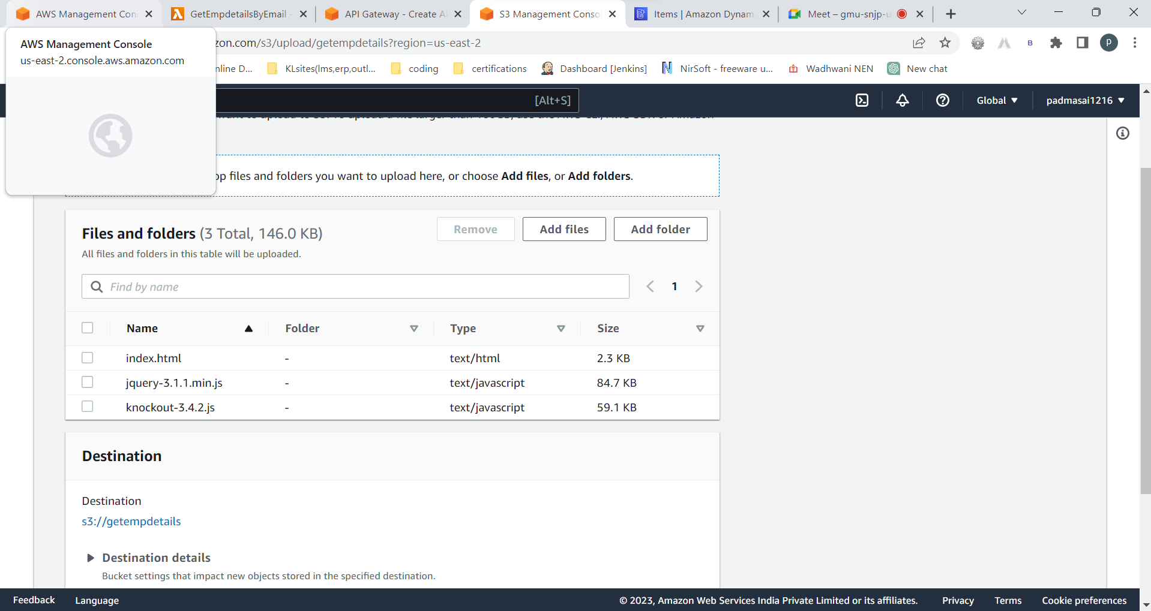

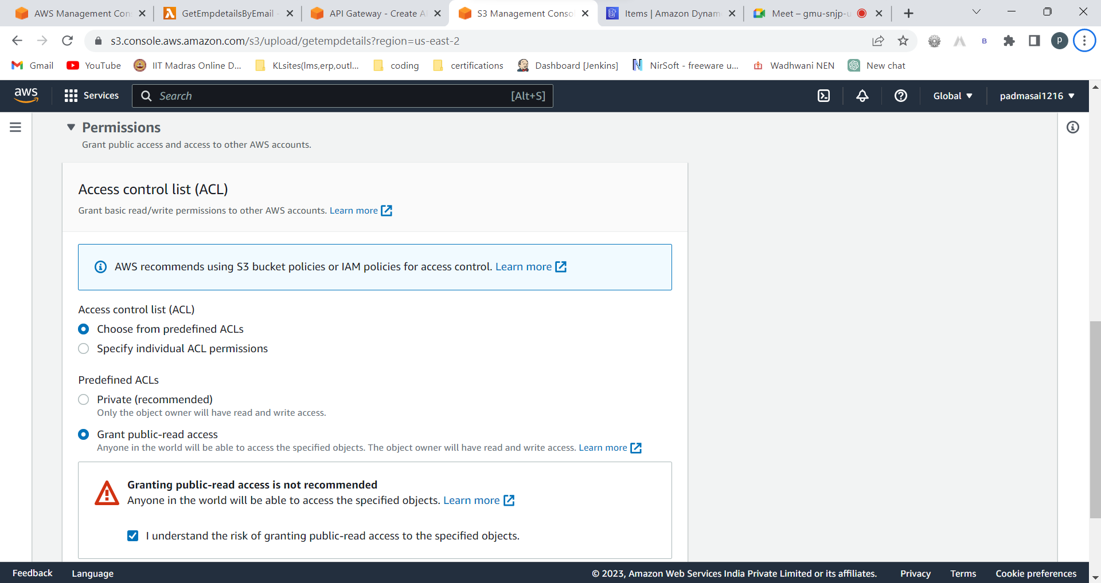

Edit bucket policy

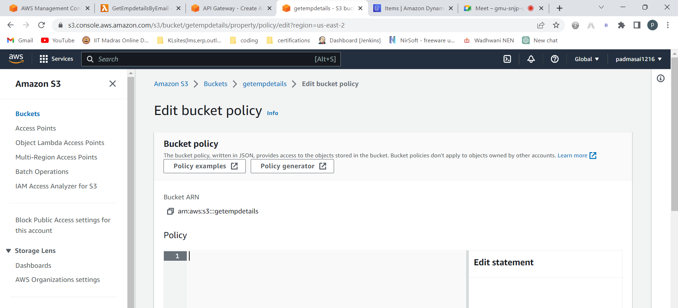

Policy generator

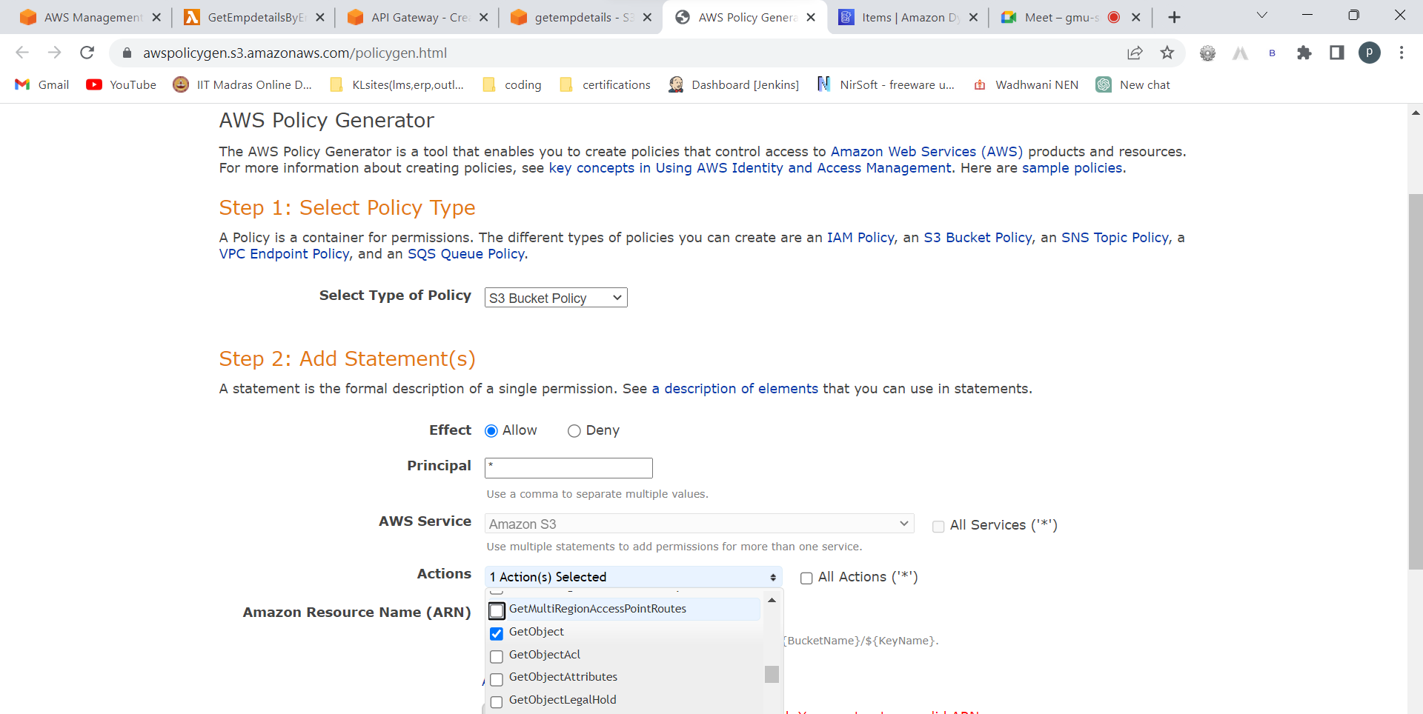

Copy arn from here

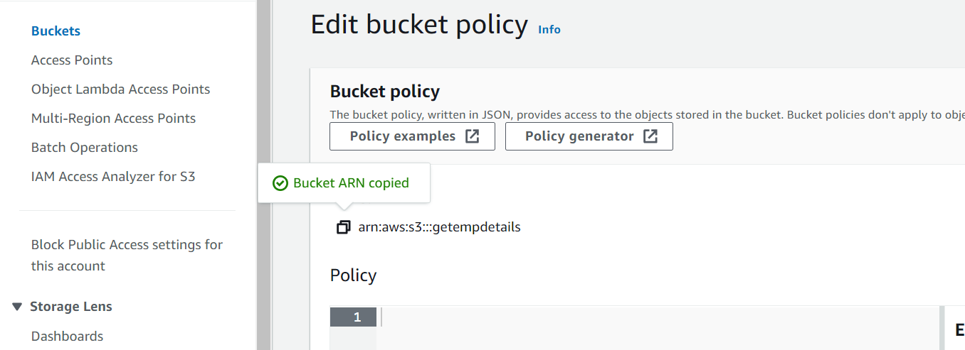

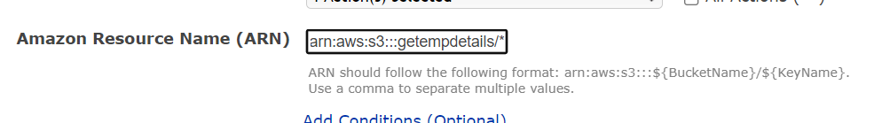

Add /* at end

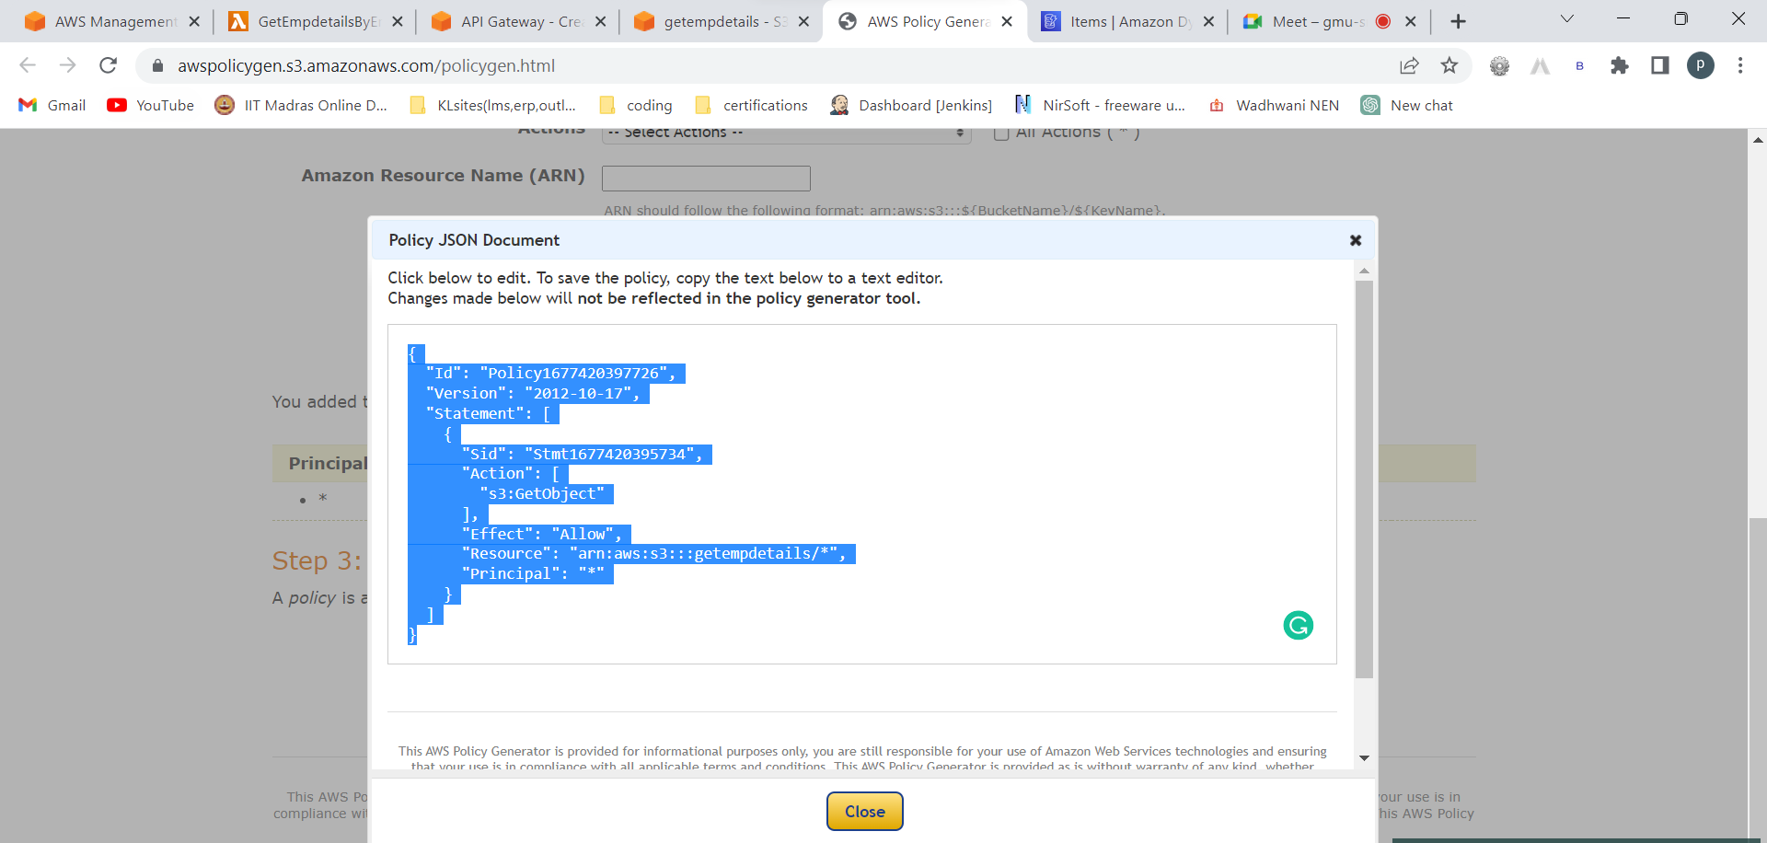

Copy this policy

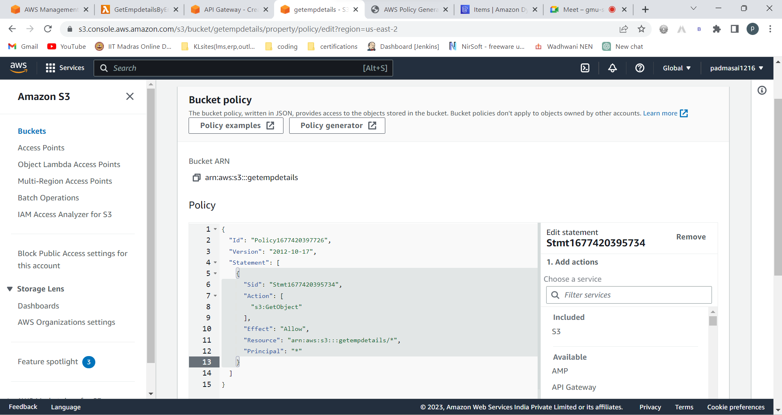

Save changes

